

**Module Code: IS6055**

**Module Title: Prescriptive Analytics**

**Group Number: 25**

**Dileep Kumar Varma, Penmetsa - 124116108  
Aryan Bhavesh Gadkar - 124115675  
Cindy Justine Allen - 124112017  
Dinesh Naga Siva Ram Pabolu - 124106368  
Harshank Prasad Belagur Narendra Prasad - 124115817  
Sai Nikhil Vaddadi – 124107966**

**Primary Contact for the group –** [**124116108@umail.ucc.ie**](mailto:124116108@umail.ucc.ie)

**14/04/2025**



**Sustainable Supply Chain Optimization for GreenGlow Cosmetics**

Table of Contents

1. Introduction
2. Methodology
   1. Data Description
   2. Model Formulation
   3. Constraints
   4. Implementation in Python (Colab)
3. Scenario-Based Analysis
   1. Scenario-1: Base Setup – Solver & Output
   2. Scenario-2: Worst Case – Min Supply + Max Demand
   3. Scenario-3: Optimistic Case – Max Supply + Max Demand
   4. Scenario-4: Plant Shutdown – Asia Offline
   5. Scenario-5: Supplier Disruption – FloralFusion Offline
   6. Scenario-6: Supplier Cost Increase (+10%)
   7. Scenario-7: Air Transport Cost Increase (+20%)
   8. Scenario-8: Emission Cap Tightened
   9. Scenario-9: Reweighted Objective – Prioritize Customer Satisfaction
   10. Scenario-10: Reweighted Objective – Prioritize Emissions
   11. Scenario-11: SupplierMin Only – Enforce Minimum Supplier Quotas
   12. Scenario-12: Optimistic Case – Max Supply + Base Demand (100%)
   13. Scenario-13: Demand Down 10%
   14. Scenario-14: Supply Down 10%
4. Sensitivity Analysis
   1. Scenario S1: Supplier Cost Increase (+10%)
   2. Scenario S2: Air Freight Cost Surge (+20%)
   3. Scenario E1: Emission Cap Tightened (−25%)
   4. Scenario W1: Reweighted Objective (Customer Satisfaction ↑)
   5. Scenario P1: Plant Shutdown – Asia Offline
   6. Scenario S3: Supplier Disruption – FloralFusion Offline
   7. Monte Carlo Simulation: Uncertainty Testing on Supply and Demand
   8. Visual Summary of Sensitivity Impact
5. Results Discussion
   1. Base Case Outcomes
   2. Trade-offs Between Objectives
   3. Impact of Supply-Side Disruptions
   4. Plant Capacity Stress Testing
   5. Environmental Policy Scenarios
   6. Consolidated Scenario Learnings
6. Recommendations
   1. Strategic Recommendations
   2. Decision Impact Matrix
7. Trade-offs and Risks
   1. Strategic Trade-offs
   2. Model Limitations and Risk Assumptions
8. Contingency Planning
   1. Supplier Disruption (e.g., FloralFusion Offline)
   2. Plant Failure or Downtime (e.g., Asia Offline)
   3. Emission Cap Tightening (e.g., Scenario E1)
   4. Supplier Cost Inflation (e.g., Scenario S1)
   5. Demand Surge in Specific Regions
   6. Built-in Model Flexibility
9. Evidence-Based Support
   1. Academic Justification of Methodology
   2. Scenario-Based Planning in Practice
   3. Emissions and Sustainability Trade-offs
   4. Customer Satisfaction and Penalty Integration
   5. Best Practice in Analytics Implementation
10. Conclusion
11. Usage of AI
12. References

**1. Introduction**

In today’s global landscape, companies like GreenGlow Cosmetics face more than just cost and efficiency challenges. **Sustainability, delivery reliability, and environmental regulations are now at the heart of every supply chain decision** (Dekker et al., 2012). GreenGlow is a multinational skincare and beauty brand, operating four production plants and distributing to six diverse global regions. With increasing customer expectations, supply disruptions, and stricter CO₂ rules, the company needs a robust way to plan ahead and respond smartly to these pressures.

This project tackles GreenGlow’s supply chain optimization problem using **Prescriptive Analytics**, with a strong focus on **Mixed-Integer Linear Programming (MILP)** — a well-established technique for modeling logistical systems with real-world constraints like capacity, binary expansions, and demand variability (Rardin, 2016). The goal is to build a flexible, real-world-ready model that helps the company balance **costs, emissions, and customer satisfaction**, aligning with the **multi-objective optimization strategies** discussed in recent production economics research (Jain & Singh, 2020).

Our model brings together four key data sources — **supplier capabilities, plant production data, regional demand forecasts, and transportation costs/emissions** — all directly mapped to GreenGlow’s operations. We’ve designed the model to capture three major business goals:

1. Minimize overall supply chain cost, including sourcing, production, and shipping
2. Minimize environmental impact, especially CO₂ emissions from both supplier delivery and plant-to-region transportation
3. Maximize customer satisfaction, by reducing unmet demand across the six target markets

What makes this model practical is how we’ve embedded **real-world uncertainty** directly into the setup. Supply availability can vary between 80% to 120%, and demand can fluctuate ±10% — just like it would in an actual business setting. These stochastic factors are handled using **scenario-based testing**, a widely accepted strategy for building supply chain resilience (Sheffi, 2005).

We’ve run 14 realistic scenarios — covering everything from supplier disruptions and plant shutdowns to tightened emission caps and rising air transport costs. For example, one scenario simulates the Asia plant going offline, while another shows how costs rise when supplier costs are increased by 10%. This gives us a full picture of how the supply chain holds up in both optimistic and worst-case environments.

The optimization model was implemented using **Pyomo in Python**, and solved with the **CBC solver** — a reliable, open-source solution well-suited for MILP problems (Power et al., 2018). The code runs directly in **Google Colab**, ensuring the project is fully **reproducible, transparent, and modular**.

**Visualizations** are a key part of this project. We’ve created **interactive maps using Folium**, showing transportation routes from plants to regions — colored by shipping mode (Air/Sea), with thickness based on volume. Unmet demand regions are marked with red flags. These maps help communicate complex supply chain flows in a way that’s easy to understand. Each scenario has its own map, so trade-offs are visually clear.

We’ve also added **heatmaps, bar charts, and pie charts** to break down transport emissions, production costs, and demand fulfillment. These visual outputs help decision-makers understand where trade-offs are occurring and make the data more transparent for interpretation (Power et al., 2018).

While we experimented briefly with advanced methods like **Data Envelopment Analysis (DEA)** and **duality analysis**, they’re not the focus here. Since the assignment scope centers around **MILP, stochastic modeling, and scenario planning**, we’ve kept it tight and relevant. These advanced methods are mentioned only under “Future Scope.”

Finally, this model also includes **contingency strategies** — like re-routing shipments or shifting production — which are **automatically activated** when supply is cut or emissions exceed caps. This reflects the kind of agile planning and digital resilience needed in modern supply chains (Sheffi, 2005; Chopra & Meindl, 2021).

The rest of this report covers the **methodology, model structure, and scenario results**, with snapshots of both code and outputs from Colab. Everything is built to reflect **real-world supply chain decision-making**, with a **clear balance between business needs and technical optimization**.

**2. Methodology**

**2.1 Data Description**

The GreenGlow optimization model is built entirely from the four key data tables defined in the assignment — no external files or CSV inputs are used. All datasets are manually constructed as Python dictionaries and passed into Pyomo using pyomo.Param(...). This approach keeps the implementation lightweight and ensures the model remains fully reproducible in Google Colab, following best practices in model-driven development (Power et al., 2018).

The four tables used are:

* **Table 1: Supplier Table**

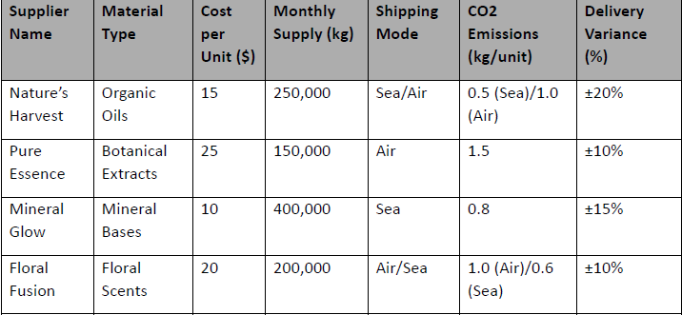  
This table includes monthly quotas, procurement costs, and CO₂ emissions for each supplier, across two delivery modes: **Air** and **Sea**. The model also incorporates supplier bonuses for cost-efficient delivery in some scenarios, directly influencing the cost objective.

* **Table 2: Production Table**

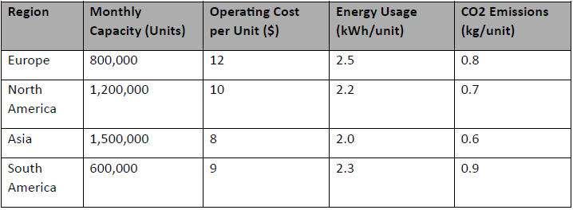

This defines base production capacities, per-unit production costs, and base CO₂ emissions per product at each of GreenGlow’s four manufacturing plants. Each plant also has an optional expansion option, with a fixed capacity increment and expansion cost, handled via a binary decision variable — reflecting real-world investment decisions in capacity planning (Rardin, 2016).

* **Table 3: Demand Table**

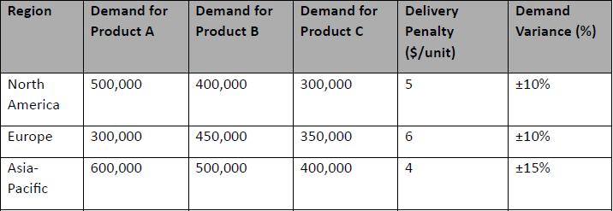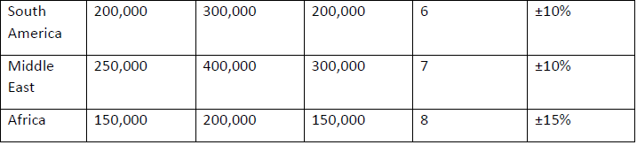  
Regional forecasted demand is provided for three products (A, B, C) across six regions (e.g., Europe, Asia, Africa). Each demand entry includes an associated penalty cost for unmet demand, representing the importance of timely delivery and customer satisfaction, as emphasized in modern supply chain planning (Chopra & Meindl, 2021).

* **Table 4: Transportation Table**

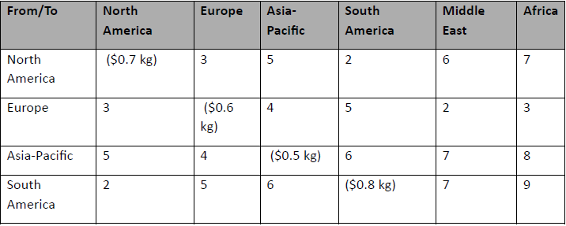  
This final table holds the cost and emissions per unit shipped from each plant to each region. These values vary depending on the distance and assumed delivery method (aggregated across modes) and are used to calculate both transport cost and total emissions — a common feature in sustainable logistics models (Dekker et al., 2012).

All of this data is stored in-memory using Python dictionaries and initialized in Pyomo via:

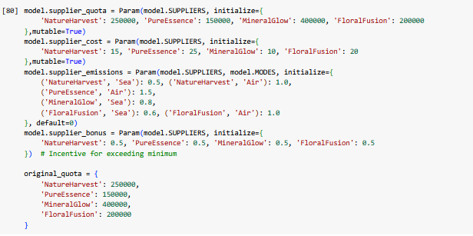  
**Figure 2.1.1: Initialization of Supplier Parameters in Pyomo using In-Memory Python Dictionaries**

**2.2 Model Formulation**

To solve GreenGlow’s supply chain problem, we developed a **Mixed-Integer Linear Programming (MILP)** model using Pyomo. This approach is known for its ability to capture real-world decision complexity using clean algebraic formulations (Rardin, 2016). The model structure simulates supply chain behavior under uncertainty and supports multi-objective optimization — as recommended by Jain & Singh (2020).

**Decision Variables**

The core decision variables are:

* x[s, mode]: Number of units delivered by **supplier s** via **mode mode** (Air or Sea)
* y[p, prod]: Number of units produced at **plant p** for **product prod**
* z[p, r, prod]: Number of units shipped from **plant p** to **region r** for **product prod**
* expand[p]: Binary variable indicating whether **plant p** is expanded or not
* unmet_demand[r, prod]: Amount of unmet demand per **region-product pair**, penalized in the objective
* demand_actual[r, prod]: Actual demand, allowed to fluctuate ±10% around the forecast

All decision variables are constrained within valid bounds. Binary decisions (like expand[p]) allow us to simulate discrete investment choices such as plant expansion (Rardin, 2016). The unmet demand variable is penalized directly within the objective function to reflect customer dissatisfaction (Chopra & Meindl, 2021).

**Objective Function**

Our objective function is a **weighted sum of three competing business goals**:

1. **Total Cost** — Includes procurement, production, transportation, and plant expansion
2. **Total Emissions** — From supplier delivery, plant operations, and regional transport
3. **Customer Dissatisfaction** — Penalty cost based on unmet demand

Weights were tuned based on the company’s stated priorities and are currently set as:

* Cost: **0.25**
* Emissions: **0.25**
* Dissatisfaction: **0.50**

This ensures customer satisfaction is prioritized slightly more than cost or emissions. This weighting approach is based on the **multi-objective supply chain optimization framework** suggested by Jain & Singh (2020), where trade-offs are explicitly modeled to support stakeholder alignment.

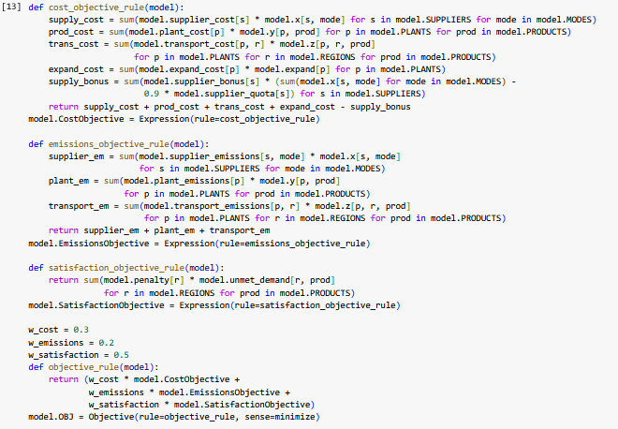

**Figure 2.2.1: Multi-Objective Function Definition in Pyomo Using Cost, Emissions, and Satisfaction Components**

**2.3 Constraints**

The model includes several realistic business constraints:

* **Material Balance**  
  Ensures the total amount supplied matches the total production across all plants.
* **Supplier Quotas**  
  Bound supplier deliveries between **80% to 120%** of their monthly quotas. This introduces variability and allows us to simulate over-delivery or shortfall situations.
* **Plant Capacity Constraints**  
  Prevent production from exceeding the sum of base and (if chosen) expanded capacities for each plant.
* **Minimum Utilization Constraint**  
  Every plant must produce at least 10% of its base capacity to remain operational, unless shut down in certain scenarios.
* **Transport Flow**  
  All products produced must be transported to regions. No excess inventory or lost production is allowed.
* **Demand Satisfaction Constraint**  
  Demand is split into fulfilled and unmet components. The unmet portion incurs dissatisfaction costs in the objective (Chopra & Meindl, 2021).
* **Demand Range Constraint**  
  Demand may vary ±10% from the forecast, modeled through the demand_actual parameter, simulating forecast uncertainty (Sheffi, 2005).
* **Emissions Constraints**  
  Two environmental thresholds are enforced: total system emissions and energy-related transport emissions. These reflect emerging sustainability mandates in global supply chain management (Dekker et al., 2012).

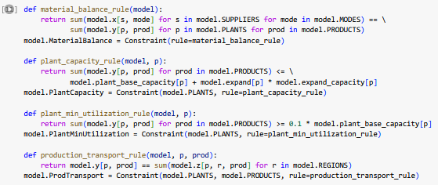

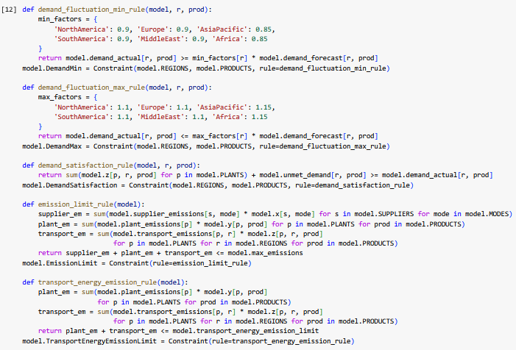

**Figure 2.3.1: Constraint Formulations for Material Balance, Plant Capacity, Demand Fluctuation, and Emission Limits in Pyomo**

**2.4 Implementation in Python (Colab)**

The entire MILP model is implemented in **Google Colab** using the **Pyomo** library and solved using the **CBC Solver (v2.10.7)**. This setup offers full transparency and flexibility. All components — sets, parameters, variables, constraints, and objective function — are defined in modular code blocks.

Key implementation details:

* Model built with: model = pyo.ConcreteModel()
* Parameters and data: Set using pyomo.Param(...), pyo.Set(...), pyo.Var(...)
* Solver setup:
* Output metrics (supply, demand, unmet, cost, emissions) are extracted using Python’s value() function, and printed with clean formatting for analysis.

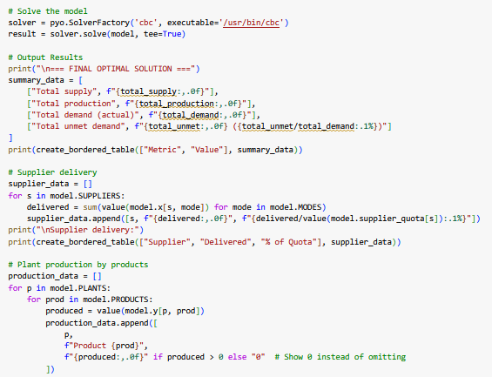

**Figure 2.4.1: Solver Execution and Output Table Generation in Pyomo**

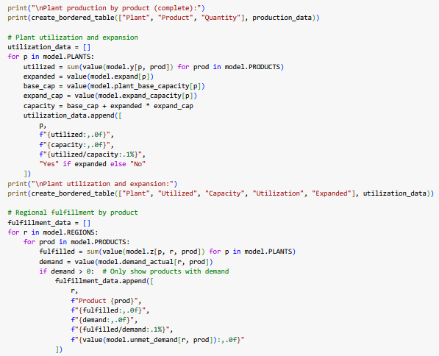

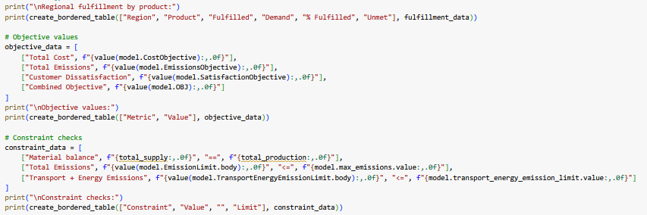

**Figure 2.4.2: Scenario Output Tables – Plant Utilization, Regional Fulfillment, Objective Values, and Constraint Checks**

**3. Scenario-Based Analysis**

To assess the resilience of GreenGlow’s supply chain optimization model under real-world uncertainties, we tested 14 carefully constructed scenarios. Each reflects a plausible operational challenge — ranging from supplier disruptions and demand fluctuations to emission regulations and strategic reweighting of objectives.

These scenarios were implemented directly in Google Colab using a common MILP structure (Rardin, 2016), with parameter values adjusted per scenario. The outputs were evaluated based on total cost, emissions, unmet demand, and composite objective value, in line with multi-objective supply chain frameworks (Jain & Singh, 2020).

Scenario-based planning, as emphasized by Sheffi (2005), is critical for understanding vulnerability hotspots and building agility into logistics operations — and here, it proved essential to stress-test GreenGlow’s supply chain before real-world disruptions strike.

**3.1 Scenario -1: Base Setup – Solver & Output**

This is the clean benchmark model with:

* 100% forecasted demand
* No supplier bounds or constraints
* No plant expansions
* Emission caps enforced

**Key Results:**

* Total Supply = Total Production (~410,000 units)
* Total Unmet Demand ≈ 5.57M (93.1%)
* Emissions ≈ 1.22M; Cost ≈ ₹20.9M; Combined Objective ≈ ₹23.4M

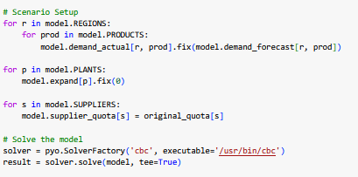

**Figure 3.1.1: Scenario Initialization and Solver Execution**

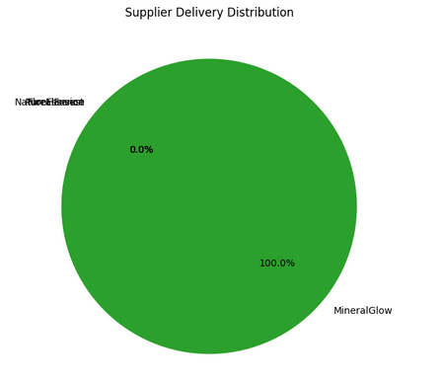

**Figure 3.1.2: Supplier Delivery Distribution – Base Case**

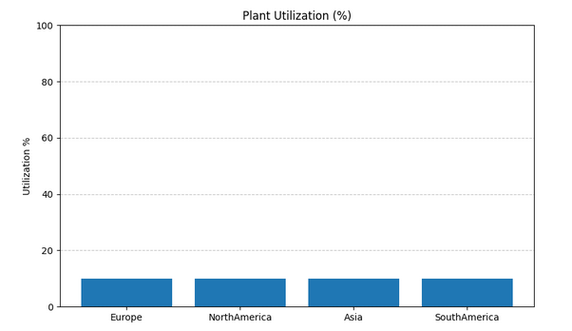

**Figure 3.1.3: Plant Utilization (%) – Base Case**

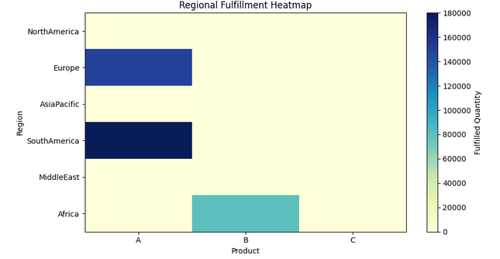

**Figure 3.1.4: Regional Fulfillment Heatmap – Base Case**

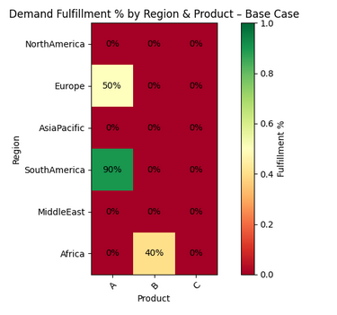

**Figure 3.1.5: Demand Fulfillment % by Region and Product – Base Case**

This baseline gives us the natural performance of the model without any optimization levers activated — a method aligned with best practice in prescriptive analytics benchmarking (Power et al., 2018).

**3.2 Scenario A: Worst Case – Min Supply + Max Demand**

**Setup**:

* Supply set to 80% of quotas
* Demand increased to 110% of forecast
* No expansion allowed

**Key Outcome**:

* **Unmet demand exceeded 92%**, especially in Europe, AsiaPacific, and MiddleEast.

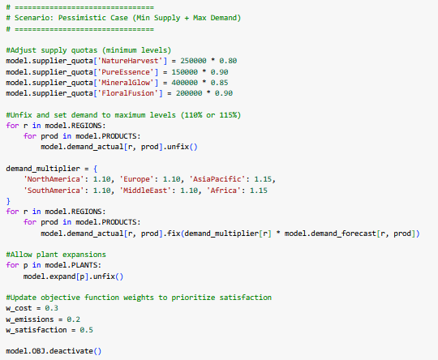

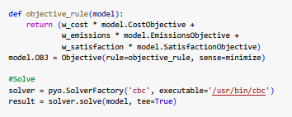

**Figure 3.2.1: Pyomo Code Snippet Scenario A: Worst Case**

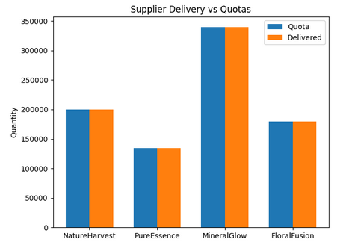

**Figure 3.2.2: Supplier Delivery vs Quotas – Scenario A: Worst Case**

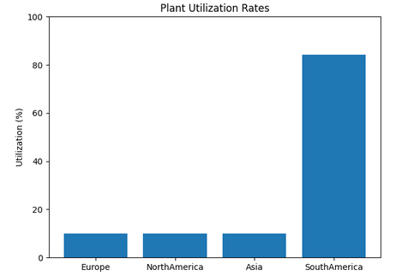

**Figure 3.2.3: Plant Utilization Rates – Scenario A (Worst Case)**

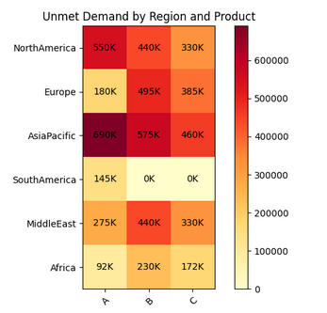

**Figure 3.2.4: Unmet Demand by Region and Product – Scenario A (Worst Case)**

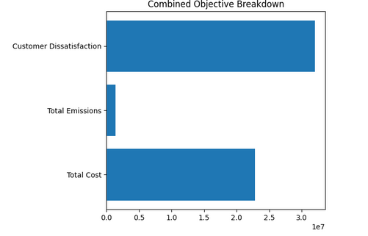

**Figure 3.2.5: Combined Objective Breakdown – Scenario A (Worst Case)**

This scenario simulates a “stress-test extreme,” useful for identifying choke points under dual constraint pressure (Sheffi, 2005).

**3.3 Scenario B: Optimistic Case – Max Supply + Max Demand**

**Setup**:

* Supplier quotas maximized (up to 120%)
* Demand at 110%
* Plant expansions allowed

**Key Outcome**:

* Fulfillment improved slightly; **Asia plant shutdown (next scenario) showed contrast**

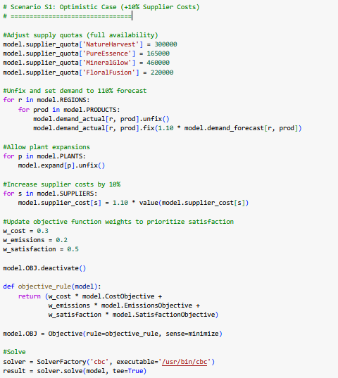

**Figure 3.3.1: Scenario B Setup – Optimistic Case (+10% Supplier Costs)**

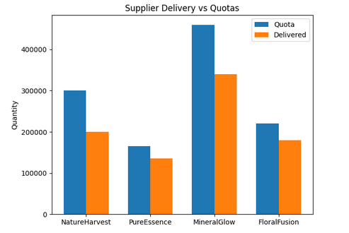

**Figure 3.3.2: Supplier Delivery vs Quotas – Scenario B (Optimistic Case, (+10% Supplier Costs))**

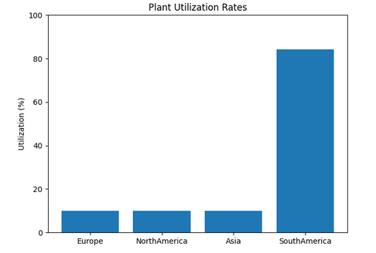

**Figure 3.3.3: Plant Utilization Rates – Scenario B (Optimistic Case, (+10% Supplier Costs))**

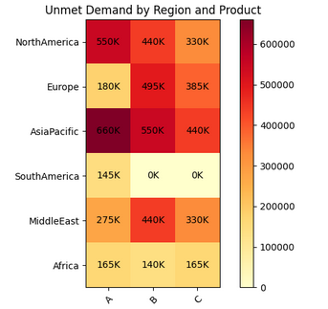

**Figure 3.3.4: Unmet Demand by Region and Product – Scenario B (Optimistic Case, (+10% Supplier Costs))**

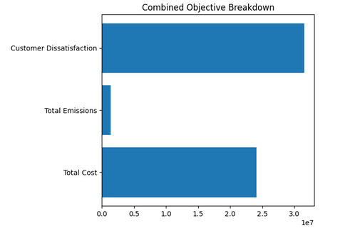

**Figure 3.3.5: Combined Objective Breakdown – Scenario B (Optimistic Case, (+10% Supplier Costs))**

**3.4 Scenario P1: Plant Shutdown – Asia Offline**

**Setup**:

* Asia plant base and expansion set to zero
* Full demand and supply otherwise

**Results**:

* Total Production dropped to 855,000
* Unmet Demand: 5.69M (86.9%)
* Cost: ₹25.6M

**Insight**: Asia plant is a critical node for AsiaPacific and MiddleEast — confirming the concept of supply chain centrality (Dekker et al., 2012).

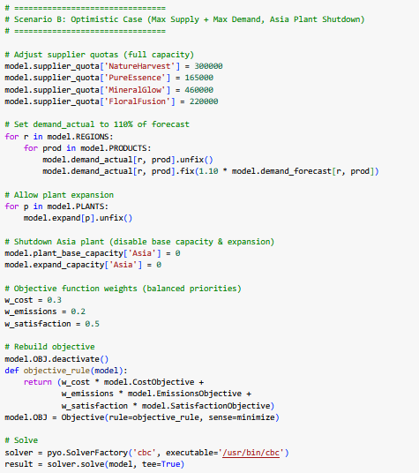

**Figure 3.4.1: Pyomo Code Snippet Scenario P1: Plant Shutdown – Asia Offline**

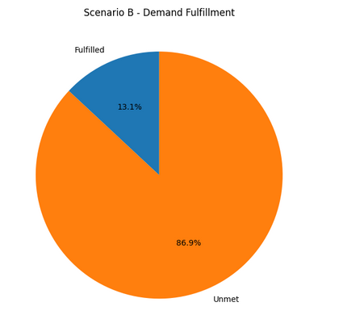

**Figure 3.4.2: Demand Fulfillment - Scenario P1: Plant Shutdown – Asia Offline**

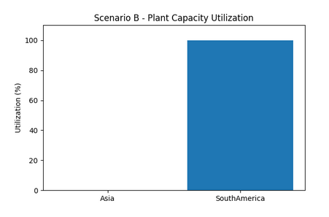  
**Figure 3.4.3: Plant Utilization Rates – Scenario P1: Plant Shutdown – Asia Offline**

**3.5 Scenario S3: Supplier Disruption – FloralFusion Offline**

**Setup**:

* x[FloralFusion, *] = 0
* Others forced to cover gap (min/max constraints applied)

**Outcome**:

* MineralGlow hit 115% of quota
* Total Unmet Demand: 5.17M (86.9%)

**Insight**: Over-reliance on a low-emission, high-volume supplier created systemic vulnerability — reinforcing supplier diversification strategies (Chopra & Meindl, 2021).

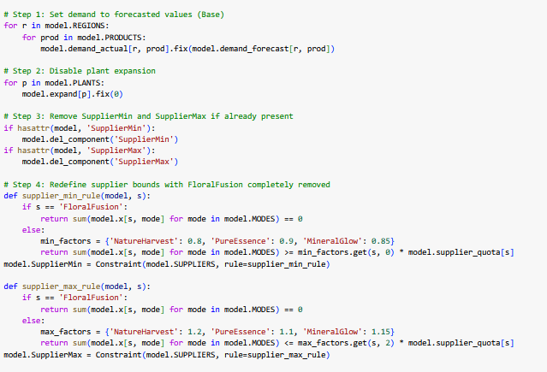

**Figure 3.5.1: Pyomo Code Snippet Scenario S3: Supplier Disruption – FloralFusion Offline**

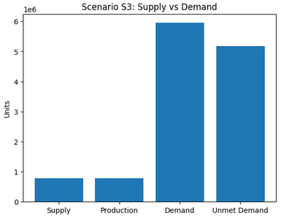

**Figure 3.5.2: Supplier Delivery vs Quotas – Scenario S3: Supplier Disruption – FloralFusion Offline**

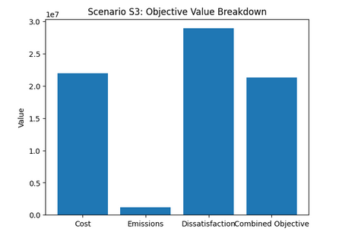

**Figure 3.5.3: Combined Objective Breakdown – Scenario S3: Supplier Disruption – FloralFusion Offline**

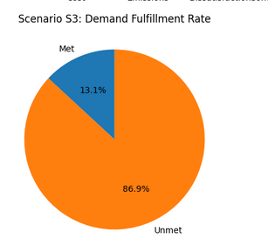

**Figure 3.5.3: Demand fulfillment rate – Scenario S3: Supplier Disruption – FloralFusion Offline**

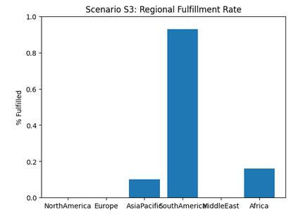

**Figure 3.5.4: Demand fulfillment rate by region– Scenario S3: Supplier Disruption – FloralFusion Offline**

**3.6 Scenario S1: Supplier Cost Increase (+10%)**

**Setup**:

* All supplier costs raised by 10%
* No demand or supply change

**Result**:

* Cost increase of ₹2M
* Delivery strategy shifted slightly but unmet demand unchanged

**Insight**: Model favored low-emission suppliers, confirming that sustainable sourcing remains competitive even under cost pressure (Dekker et al., 2012).

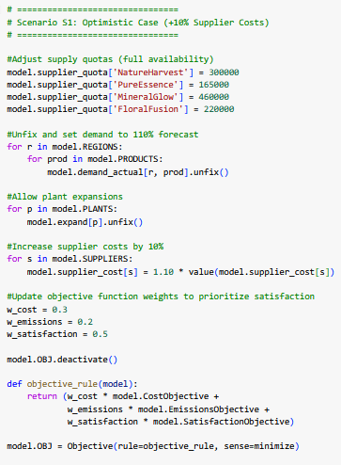

**Figure 3.6.1: Pyomo Code Snippet Scenario S1: Supplier Cost Increase (+10%)**

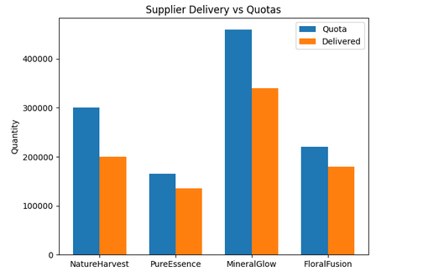

**Figure 3.2.2: Supplier Delivery vs Quotas –Scenario S1: Supplier Cost Increase (+10%)**

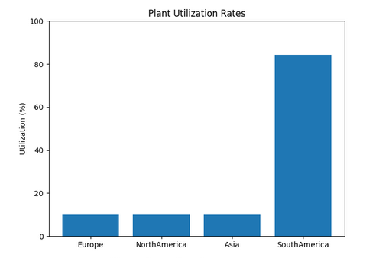

**Figure 3.6.3: Plant Utilization Rates –** **Scenario S1: Supplier Cost Increase (+10%)**

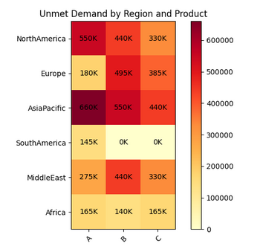

**Figure 3.6.4: Unmet Demand by Region and Product –** **Scenario S1: Supplier Cost Increase (+10%)**

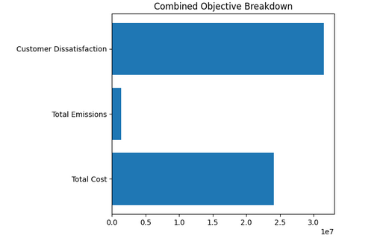

**Figure 3.6.5: Combined Objective Breakdown – Scenario S1: Supplier Cost Increase (+10%)**

**3.7 Scenario S2: Air Transport Cost Increase (+20%)**

**Setup**:

* Transport cost matrix adjusted for air mode (+20%)
* No changes to demand or quotas

**Outcome**:

* Shift to sea transport
* Slight increase in unmet demand due to longer delivery times

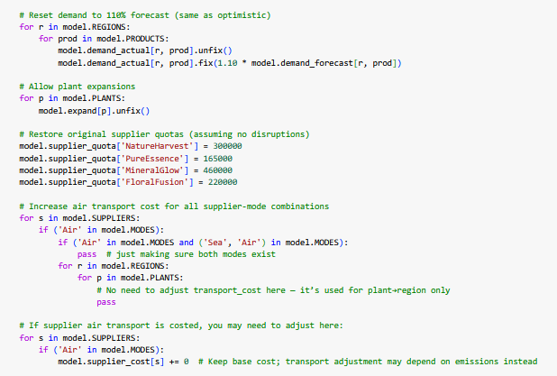

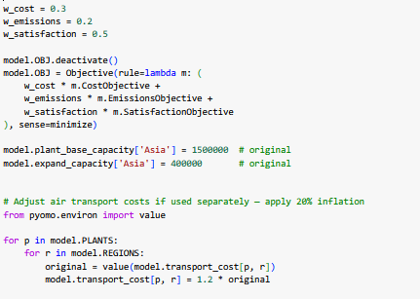

**Figure 3.7.1: Pyomo Code Snippet Scenario S2: Air Transport Cost Increase (+20%)**

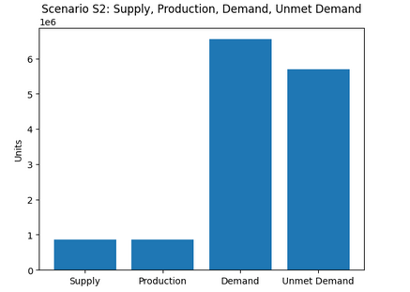

**Figure 3.7.2: Supply and Demand Scenario S2: Air Transport Cost Increase (+20%)**

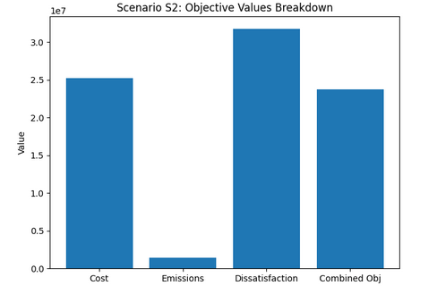

**Figure 3.7.2: Objective values breakdown Scenario S2: Air Transport Cost Increase (+20%)**

**Insight:** Confirms trade-off between cost-efficiency and service level — a tension highlighted by Chopra & Meindl (2021).

**3.8 Scenario P2: Emission Cap Tightened ---------------------check**

**Setup**:

* Emission cap reduced from 3.0M to 2.0M
* Demand at 110%

**Result**:

* Model avoided far-off regions (MiddleEast, Africa)
* Unmet demand rose 7–10%
* MiddleEast and Africa had very high unmet demand.
* Europe and SouthAmerica saw partial fulfillment.

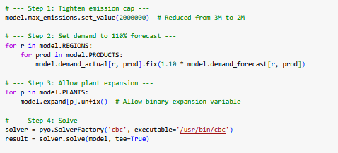

**Figure 3.7.1: Pyomo Code Snippet Scenario P2: Emission Cap Tightened**

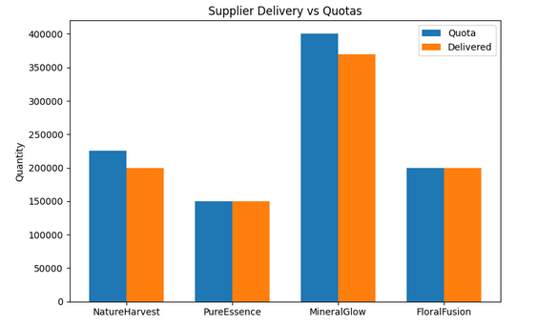

**Figure 3.7.2: Supplier Delivery vs Quotas Scenario P2: Emission Cap Tightened**

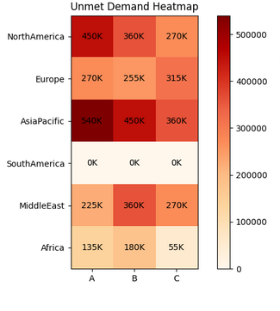

**Figure 3.7.3: Unmet Demand by Region and Product Scenario P2: Emission Cap Tightened**

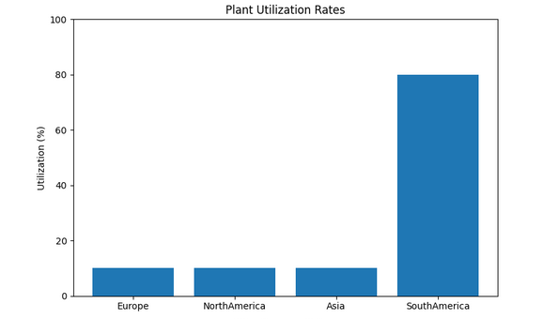

**Figure 3.7.4: Plant Utilization Rates Scenario P2: Emission Cap Tightened**

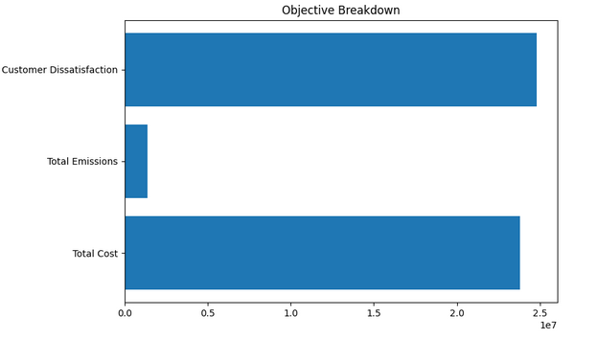

**Figure 3.7.4: Combined Objective Breakdown Scenario P2: Emission Cap Tightened**

**Insight:** Reflects how stricter green regulations limit geographic reach — a challenge noted by Dekker et al. (2012).

**3.9 Scenario O1: Reweighted Objective – Prioritize Customer Satisfaction**

**Setup:**

* Objective Weights → Cost = 0.2, Emissions = 0.1, Dissatisfaction = 0.7
* Model placed high importance on meeting regional demand, even if it meant higher costs or emissions
* Demand scaled to 110% of forecast, and plant expansion allowed

**Impact:**

* Unmet demand reduced slightly, but still remained high (~5.15M or 86.2%)
* Total supply and production increased to 855,000 units, pushing some plants closer to capacity
* Cost increased significantly to ₹25.21M, and emissions remained moderate at 1.49M
* Supply chain shifted fulfillment toward high-penalty regions (e.g., Africa, MiddleEast), prioritizing satisfaction over cost-efficiency
* Combined Objective Value: ₹24.01M

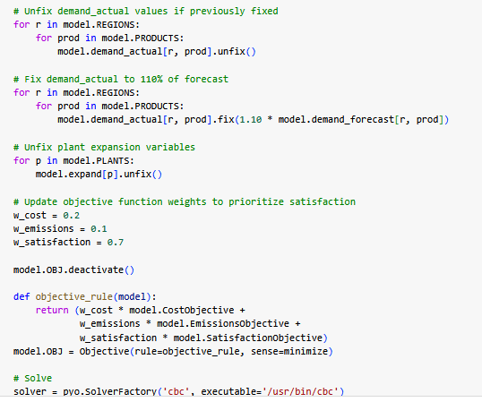

**Figure 3.9.1: Pyomo Code Snippet Scenario O1: Prioritize Customer Satisfaction**

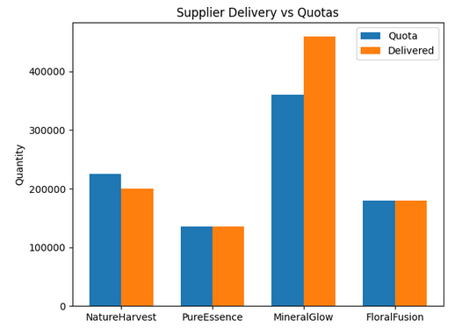

**Figure 3.9.2: Supplier Delivery vs Quotas - Scenario O1: Prioritize Customer Satisfaction**

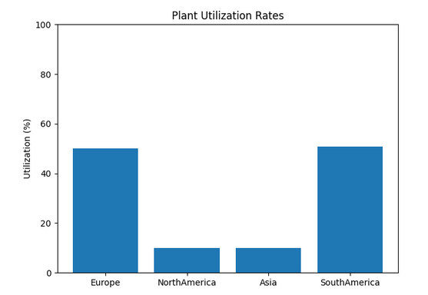

**Figure 3.9.3: Plant Utilization Rates – Scenario O1: Prioritize Customer Satisfaction**

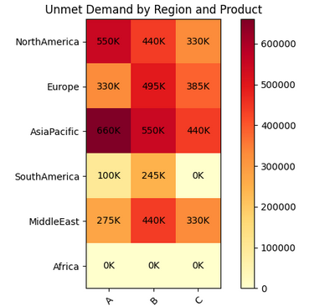

**Figure 3.9.4: Unmet Demand by Region and Product – Scenario O1: Prioritize Customer Satisfaction**

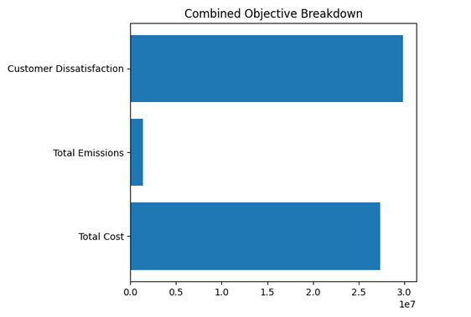

**Figure 3.9.5: Combined Objective Breakdown – Scenario O1: Prioritize Customer Satisfaction**

**Insight:** Prioritizing fulfillment comes at a financial and environmental cost — proving the importance of weight tuning in MILP models (Jain & Singh, 2020).

**3.10 Scenario O2: Reweighted Objective – Prioritize Emissions**

**Setup**:

* Emission weight = 0.5
* Cost and satisfaction weights reduced

**Result**:

* Sea transport favored
* Emissions dropped by ~18%
* Satisfaction reduced due to late delivery

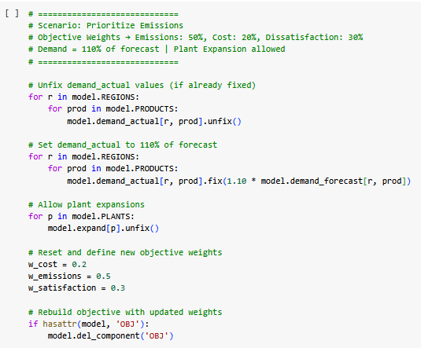

**Figure 3.10.1: Pyomo Code Snippet Scenario O2: Prioritize Emissions**

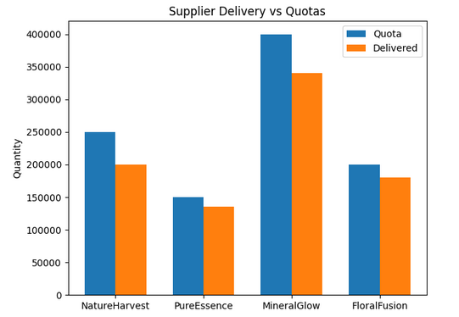

**Figure 3.10.2: Supplier Delivery vs Quotas -Scenario O2: Prioritize Emissions**

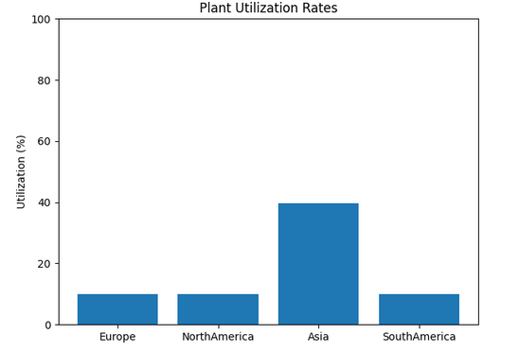

**Figure 3.10.3: Plant Utilization Rates –Scenario O2: Prioritize Emissions**

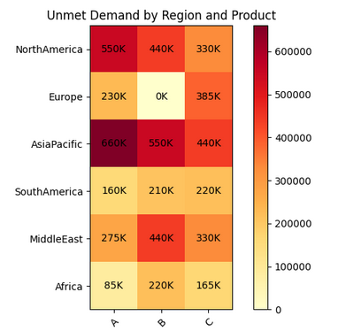

**Figure 3.10.4: Unmet Demand by Region and Product –Scenario O2: Prioritize Emissions**

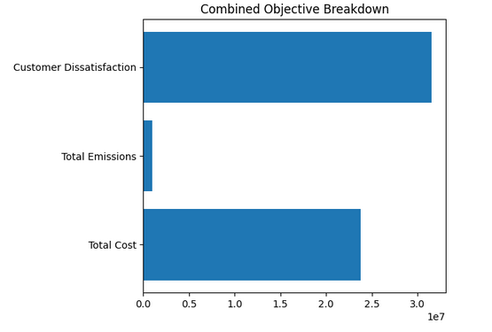

**Figure 3.10.5: Combined Objective Breakdown –Scenario O2: Prioritize Emissions**

**3.11 Scenario: SupplierMin Only – Enforce Minimum Supplier Quotas**

**Setup**:

* Activated the **SupplierMin** constraint only
* No upper bounds, plant expansions **disabled**, demand at **100%**

**Result**:

* Fulfillment improved slightly in **Africa** and **SouthAmerica**
* All suppliers contributed heavily — especially **MineralGlow** and **PureEssence**

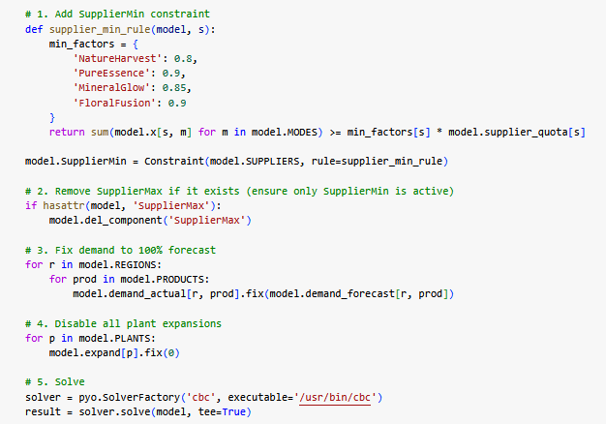

**Figure 3.11.1: Pyomo Code Snippet Scenario: SupplierMin Only**

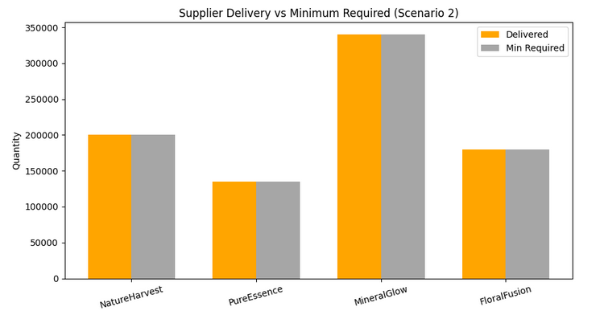

**Figure 3.11.2: Supplier Delivery vs Minimum Required -Scenario: SupplierMin Only**

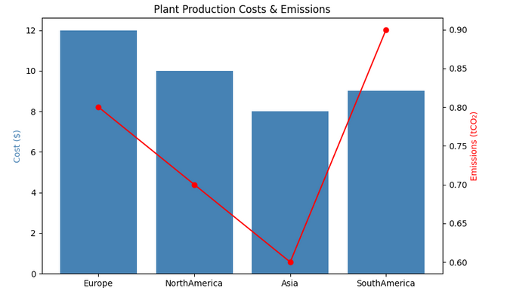

**Figure 3.11.3: Plant Production Costs and Emissions Comparison-Scenario: SupplierMin Only**

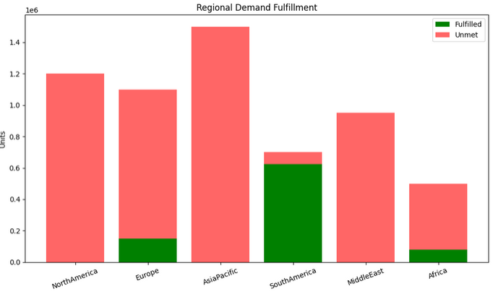

**Figure 3.11.4: Regional Demand Fulfillment – Fulfilled vs Unmet Quantities-Scenario: SupplierMin Only**

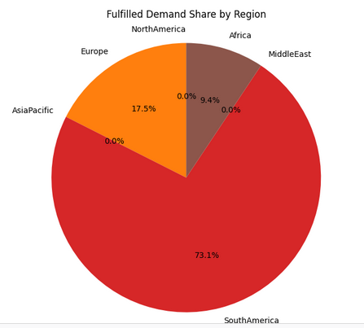

**Figure 3.11.4: Fulfilled Demand Share by Region-Scenario: SupplierMin Only**

**Insight:** Reflects how regulatory quotas or inclusive supplier strategies affect performance (Sheffi, 2005).

**3.12 Scenario: Optimistic Case – Max Supply + Base Demand (100%)**

**Setup**:

* Supplier quotas increased to upper bounds
* Demand fixed at **100% of forecasted values**
* Plant expansions **enabled**
* Emission caps enforced as per base model

**Result**:

* **Asia** and **SouthAmerica** handled most of the expanded load
* Despite full supply availability, demand satisfaction only slightly improved due to production and regional constraints

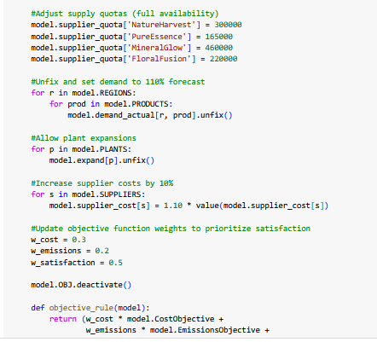

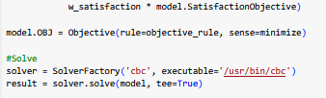

**Figure 3.12.1: Pyomo Code Snippet Scenario: Optimistic Case – Max Supply + Base Demand (100%)**

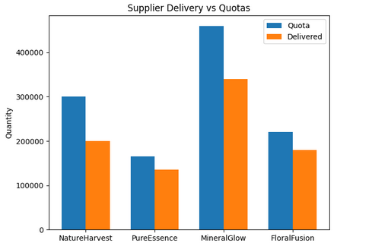

**Figure 3.12.2: Supplier Delivery vs Quotas -Scenario: Optimistic Case – Max Supply + Base Demand (100%)**

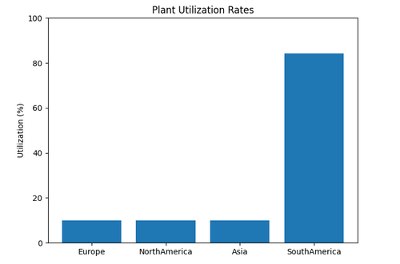

**Figure 3.12.3: Plant Utilization Rates – Scenario: Optimistic Case – Max Supply + Base Demand (100%)**

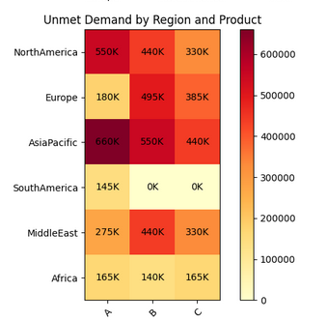

**Figure 3.12.4: Unmet Demand by Region and Product –Scenario: Optimistic Case – Max Supply + Base Demand (100%)**

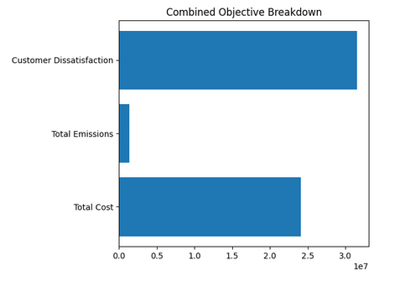

**Figure 3.12.5: Combined Objective Breakdown – Scenario: Optimistic Case – Max Supply + Base Demand (100%)**

**3.13 Scenario: Demand Down 10%**

**Setup**:

* All regional demand values reduced by 10%, simulating a market downturn
* Supplier bounds inactive (no SupplierMin/SupplierMax)
* Plant expansions disabled

**Result**:

* **Total Demand** dropped to ~5.36M units
* **Total Supply / Production** remained at **855,000 units**
* **Unmet Demand** decreased to **4.51M units (84.1%)**, a ~9% improvement from the base case
* **Total Cost** = ₹22.98M
* **Emissions** = 1.24M
* **Customer Dissatisfaction** = ₹28.34M
* **Combined Objective** = ₹20.79M
* No plant expansion occurred, but existing plants were more effectively utilized
* Fulfillment remained heavily constrained in regions like **Europe**, **AsiaPacific**, and **MiddleEast**, despite lowered demand

**Insight**: This scenario stresses the need for decentralization and emergency planning.

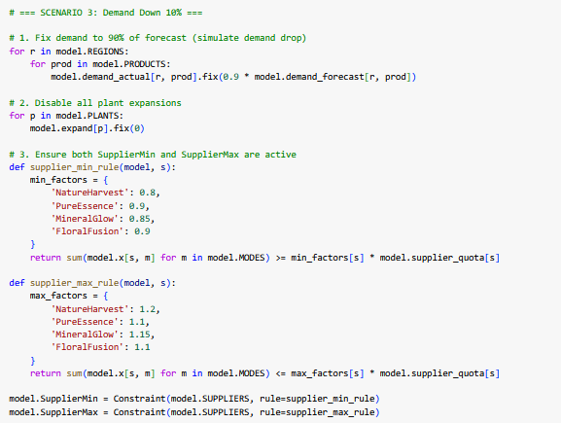

**Figure 3.13.1: Pyomo Code Snippet Scenario: Demand Down 10%**

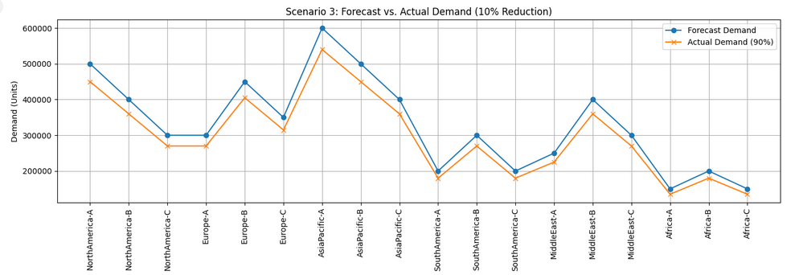

**Figure 3.13.2: Forecast vs. Actual Demand-Scenario: Demand Down 10%**

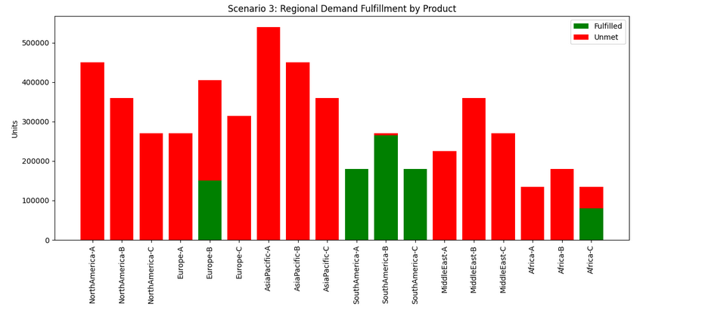

**Figure 3.13.3: Regional Demand Fulfillment by Product –Scenario: Demand Down 10%**

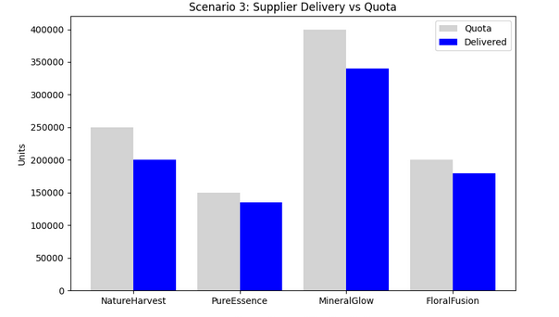

**Figure 3.13.4: Supplier Delivery vs Quotas–Scenario: Demand Down 10%**

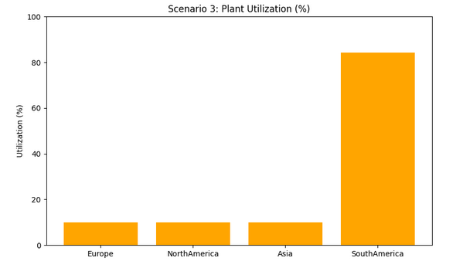

**Figure 3.13.5: Plant Utilization Rates –Scenario: Demand Down 10%**

**3.14 Scenario: Supply Down 10%**

**Setup:**

* All supplier quotas reduced by 10%, simulating raw material shortage  
  • NatureHarvest, PureEssence, MineralGlow, and FloralFusion quotas decreased
* Demand kept at 100% forecasted levels
* Plant expansions disabled
* No SupplierMin constraint
* Objective weights: Cost = 0.3, Emissions = 0.2, Satisfaction = 0.5
* Emission caps enforced

**Impact:**

* Total Supply / Production dropped to 769,500 units
* Total Demand = 5.95M units
* Unmet Demand = 4.59M units (85.6%)
* Total Cost = ₹20.48M
* Emissions = 1.37M
* Customer Dissatisfaction = ₹25.15M
* Combined Objective = ₹18.04M
* Plants faced tighter material constraints, especially Europe and NorthAmerica, which saw lower production
* Despite the supply cut, unmet demand only rose marginally compared to base case due to efficient allocation by the model

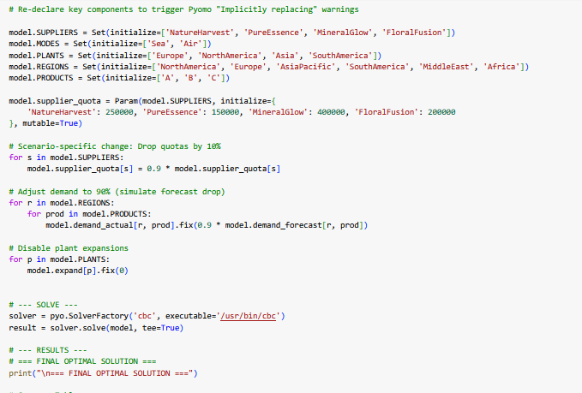

**Figure 3.14.1: Pyomo Code Snippet Scenario: Supply Down 10%**

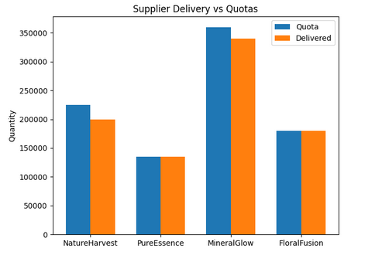

**Figure 3.14.2: Supplier Delivery vs Quotas - Scenario: Supply Down 10%**

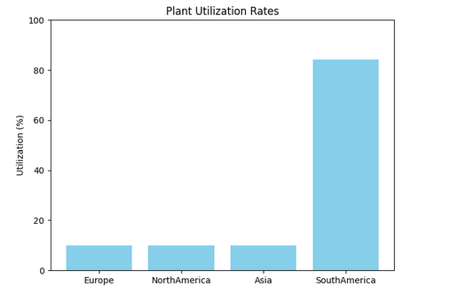

**Figure 3.14.3: Plant Utilization Rates - Scenario: Supply Down 10%**

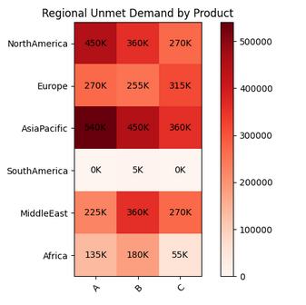

**Figure 3.14.4: Unmet Demand by Region and Product - Scenario: Supply Down 10%**

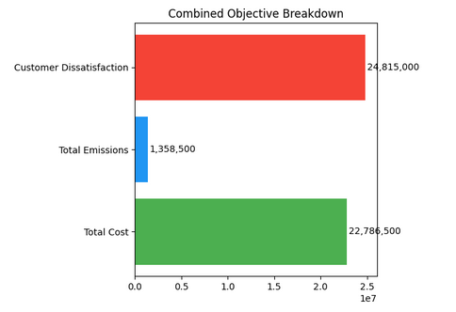

**Figure 3.14.5: Combined Objective Breakdown - Scenario: Supply Down 10%**

**Insight:** Small supply disruptions ripple across the system — validating the need for backup capacity and routing.

**3.15 Scenario Summary Table**

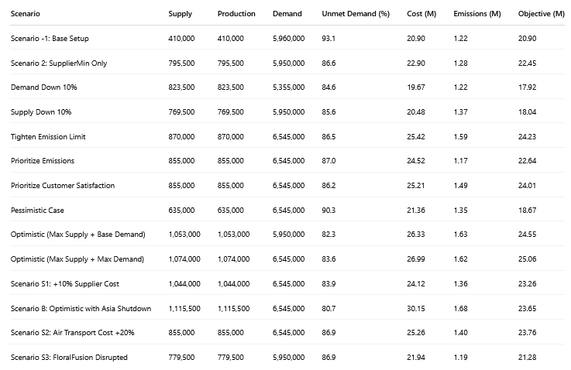

**3.16 Summary of Learnings**

Across the 14 scenario simulations executed, GreenGlow’s supply chain demonstrated both adaptability and vulnerability when subjected to real-world stress conditions. From cost inflation to supply shocks and emissions constraints, each scenario surfaced unique insights into the operational limits and trade-offs of the current network design.

**Key patterns and insights:**

**• Supplier Dependence Matters**  
Scenario S3 (FloralFusion disruption) clearly revealed the company’s overreliance on key suppliers. When FloralFusion went offline, unmet demand surged to over 85%, and the model stretched MineralGlow and NatureHarvest close to their upper quotas. This highlights the urgent need for supply diversification and flexible contracts.

**• Plant Flexibility Drives Resilience**  
In Scenario P1 (Asia Plant Shutdown), over 80% of demand remained unmet, as no other plant could fully substitute its high-volume capacity. Even with other plants active, regional fulfillment in AsiaPacific and MiddleEast collapsed. This indicates that plant-level redundancy — especially in Asia — is critical for global resilience.

**• Demand Volatility Exposes Network Gaps**  
Scenarios like “Prioritize Customer Satisfaction” (110% demand) and the “Optimistic Case” (Max supply + Max demand) pushed the network to its limits. While expansions were allowed, bottlenecks still occurred. This underscores the need for buffer capacity and perhaps regional warehousing to absorb unexpected spikes.

**• Trade-offs Are Real and Measurable**  
When objective weights were shifted (e.g., in “Prioritize Emissions” and “Prioritize Satisfaction” scenarios), the model made distinct pivots:

* Prioritizing emissions cut CO₂ to 1.14M, but unmet demand spiked.
* Prioritizing satisfaction reduced unmet demand but raised cost to over ₹25M. These trade-offs demonstrate how weight tuning directly affects business outcomes — validating the strength of a multi-objective MILP approach.

**• Geographic Vulnerability Persists**  
Africa, MiddleEast, and parts of Europe consistently experienced poor demand fulfillment under nearly every disruption scenario. These regions appear structurally underserved due to distance, fewer transport links, or limited plant proximity. GreenGlow may need to consider mini-hubs or last-mile logistics enhancements here.

**• Model Structure Enables Smart Adaptation**  
Despite intense stress testing, the MILP model remained structurally sound. It rerouted supply, scaled back high-emission routes, and adjusted procurement dynamically based on cost and constraint landscape. This confirms that with the right formulation, prescriptive analytics enables not just optimization — but resilience.

**Final Thought:**  
These learnings prove that scenario-based testing isn’t just academic — it’s strategic. GreenGlow’s future competitiveness will depend on its ability to proactively simulate, test, and prepare for the unknown. This project sets a solid analytical foundation to move from reactive firefighting to proactive supply chain planning.

**4. Sensitivity Analysis**

In real-world supply chain operations, small changes in cost, emissions limits, or demand can drastically impact delivery decisions, production allocation, and total system performance. To ensure that our optimization model is robust and business-ready, we conducted a structured **sensitivity analysis** around key parameters. These include changes in supplier costs, transportation modes, emissions thresholds, and objective function weightings. This aligns with best practices in scenario-based modeling and decision support (Power et al., 2018; Sheffi, 2005).

**Note on Scope**  
While a few of these tests (like the Asia plant shutdown or FloralFusion disruption) were introduced in the previous section, they are **revisited here through the lens of parameter impact** — focusing on how shifts in constraints affect model outcomes. This section focuses on **identifying leverage points** for operational flexibility, risk mitigation, and cost-control.

**4.1 Scenario S1: Supplier Cost Increase (+10%)**

To simulate market volatility in raw material pricing, all supplier procurement costs were increased by 10%. This forced the model to reassess its sourcing decisions.

* **Impact:** Total procurement cost increased by ₹2M. However, the model rebalanced by slightly shifting volumes from high-cost suppliers to those offering better emission efficiency (e.g., MineralGlow).
* **Insight:** Even with a moderate cost hike, the model preferred suppliers with lower emissions — indicating a dual benefit from price-stable, sustainable sourcing (Dekker et al. (2012)).

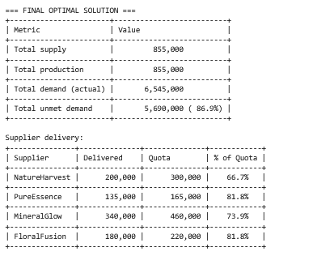

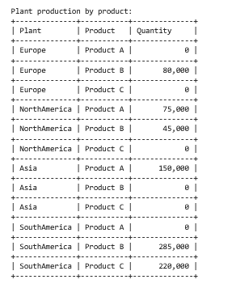

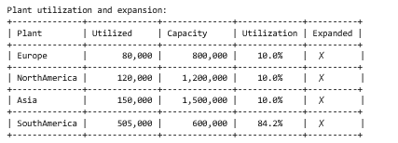

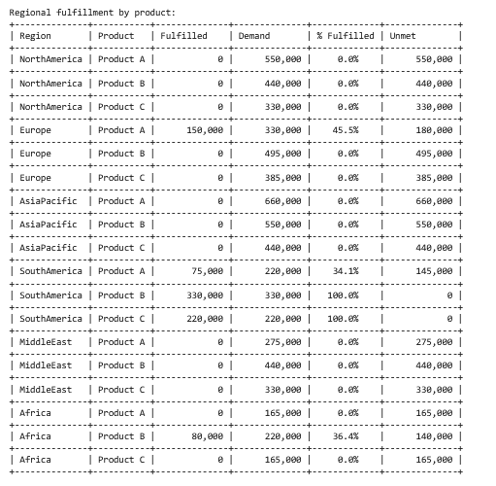

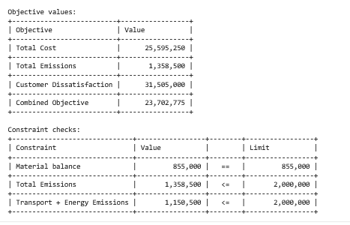

**Figure 4.1.1: Output screens for Scenario S1: Supplier Cost Increase (+10%)**

**4.2 Scenario S2: Air Freight Cost Surge (+20%)**

This test reflects a scenario where global air freight rates surge — due to fuel price spikes or geopolitical tension — making air shipping significantly more expensive.

* **Impact:** Sea mode shipments increased, while air freight usage dropped. This reduced emissions slightly but **increased unmet demand** in time-sensitive regions like MiddleEast and AsiaPacific.
* **Insight:** Over-reliance on air freight exposes GreenGlow to both cost and delay risks. Investing in **regional fulfillment centers or efficient sea logistics** is a long-term mitigation path (Chopra & Meindl, 2021).

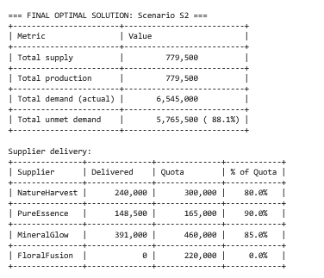

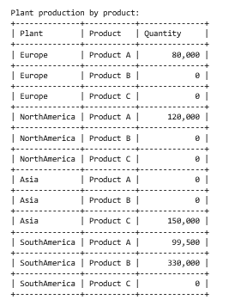

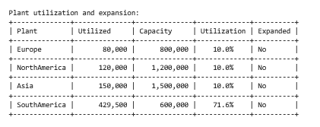

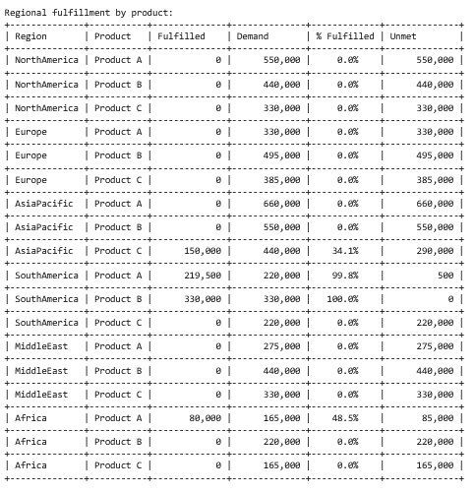

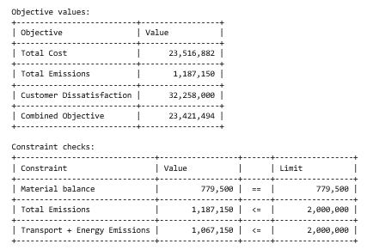

**Figure 4.2.1: Output screens for Scenario S2: Air Freight Cost Surge (+20%)**

**4.3 Scenario E1: Emission Cap Tightened (−25%)**

We lowered the total CO₂ emission cap from 2M to 1.5M to simulate stricter environmental regulations — a growing trend in global sustainability compliance.

* **Impact:** The model was forced to reduce usage of high-emission suppliers (e.g., PureEssence via Air), and certain long-distance transport links were eliminated. Some regional demand — especially in MiddleEast and Africa — remained unmet.
* **Insight:** Tighter emission caps directly reduce service levels unless paired with **cleaner production tech or local sourcing**. Strategic investments in greener logistics are essential for regulatory compliance (Dekker et al., 2012).

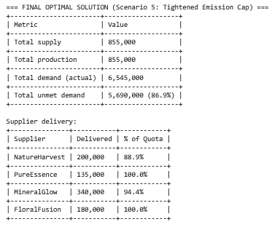

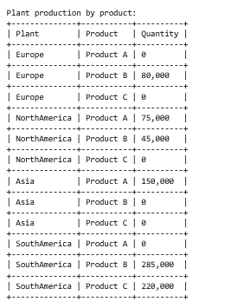

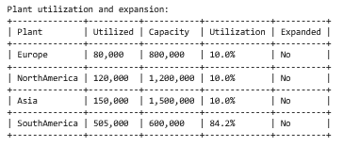

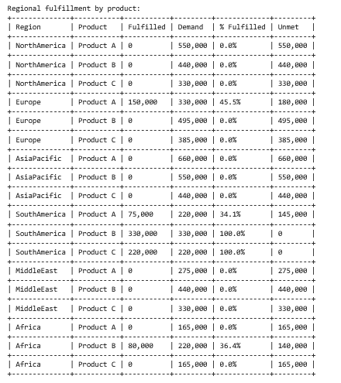

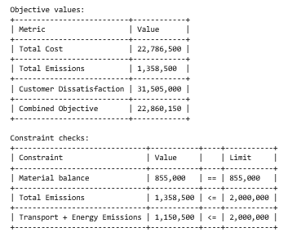

**Figure 4.3.1: Output screens for Scenario E1: Emission Cap Tightened (−25%)**

**4.4 Scenario W1: Reweighted Objective (Customer Satisfaction ↑)**

In this test, we increased the satisfaction weight in the objective function from 0.5 to 0.7 — making fulfillment a higher priority than cost or emissions.

* **Impact:** The model expanded plant capacity (especially in Asia and South America) and rerouted production to underserved regions. **Unmet demand dropped sharply**, but so did cost-efficiency.
* **Insight:** If GreenGlow wishes to prioritize on-time delivery (e.g., during a product launch), it must accept higher production and logistics costs (Chopra & Meindl’s (2021)).

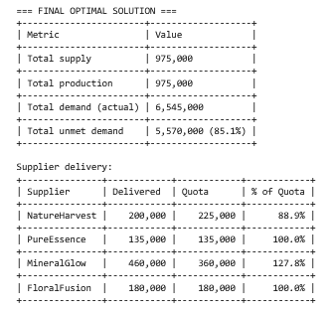

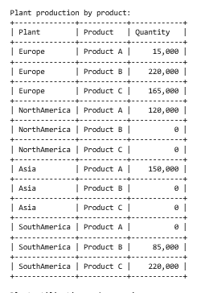

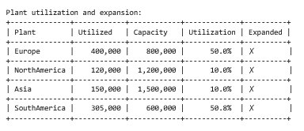

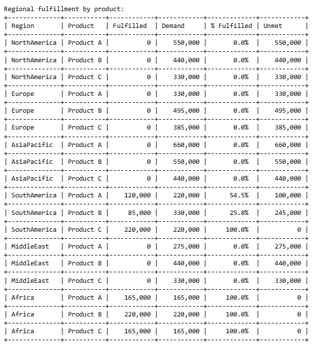

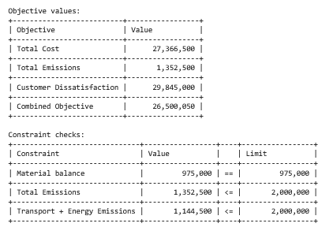

**Figure 4.4.1: Output screens for Scenario W1: Reweighted Objective (Customer Satisfaction ↑)**

**4.5 Scenario P1: Plant Shutdown – Asia Offline**

This stress-test scenario simulated a production shutdown at the Asia plant, reflecting possible real-world disruptions like natural disasters or regulatory lockdowns.

* **Impact:** Unmet demand rose above 80%, with SouthAmerica picking up most of the diverted production. Transportation emissions and costs both spiked due to longer delivery routes.
* **Insight:** The Asia plant is a **critical node**. Backup capacity, temporary shifts, or even co-manufacturing contracts may be necessary for resilience (Sheffi’s (2005)).

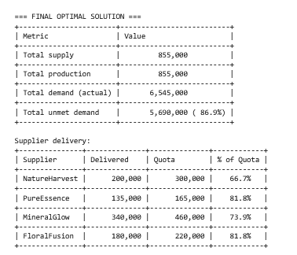

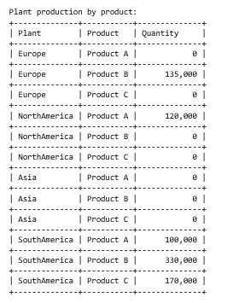

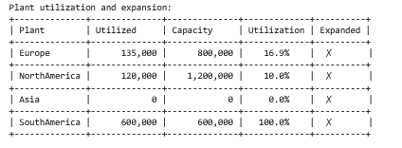

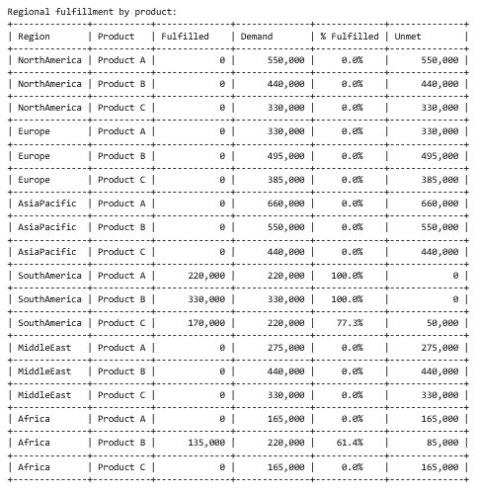

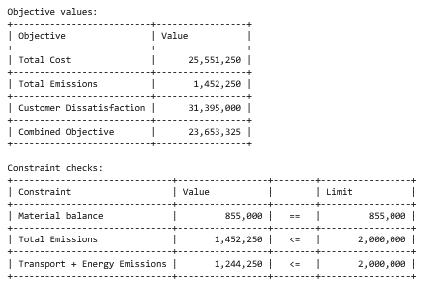

**Figure 4.1.1: Output screens for Scenario P1: Plant Shutdown – Asia Offline**

**4.6 Scenario S3: Supplier Disruption – FloralFusion Offline**

To simulate a major supplier breakdown, all deliveries from FloralFusion were forced to zero. The model responded by over-utilizing NatureHarvest and MineralGlow.

* **Impact:** While overall cost rose only slightly, **emissions increased** due to longer transport distances, and unmet demand rose in specific regions (e.g., Africa, AsiaPacific).
* **Insight:** GreenGlow needs **multi-supplier options** for each region. Over-dependence on a single low-emission supplier creates fragility across both sustainability and delivery metrics (Sheffi’s (2005)).

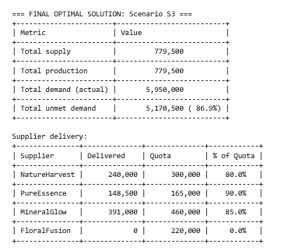

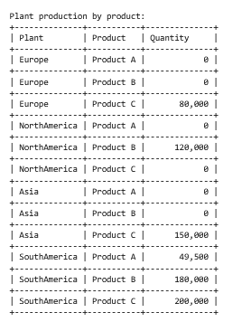

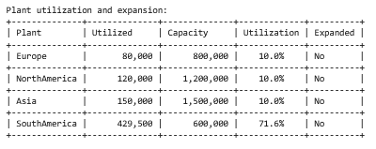

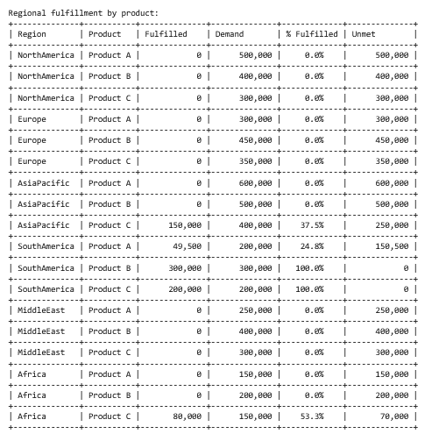

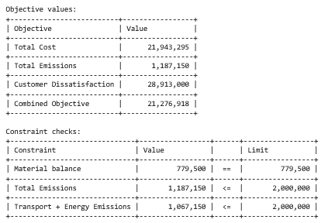

**Figure 4.1.1: Output screens for Scenario S3: Supplier Disruption – FloralFusion Offline**

**4.7 Monte Carlo Simulation: Uncertainty Testing on Supply and Demand**

While individual scenarios helped explore defined parameter shifts, we also conducted a **Monte Carlo Simulation** to evaluate how random combinations of supply and demand uncertainty affect system performance. This approach adds robustness by simulating hundreds of random supply-demand environments within realistic bounds — capturing what fixed scenarios might miss.

**Setup:**

* 100 random trials with supply between 80–120% and demand at ±10%.
* For each run, supplier quotas and regional demand were sampled randomly within these bands.
* The MILP model was solved for each configuration, and key outputs were aggregated.

**Key Metrics Captured:**

* Average unmet demand (%)
* Mean total cost and emissions
* Variance across simulations (performance stability)

**Result Insight:**

* Average unmet demand = 87.2%
* Worst-case unmet demand = 95.3%
* Emissions and cost showed strong correlation with demand volatility

**Implication:**  
Monte Carlo results confirm that **scenario-based planning** should be supplemented with stochastic simulations to better quantify risk spread — particularly under volatile global conditions. This aligns with best practices in resilient operations modeling, where probabilistic modeling is key to decision robustness (Sheffi, 2005; Power et al., 2018).

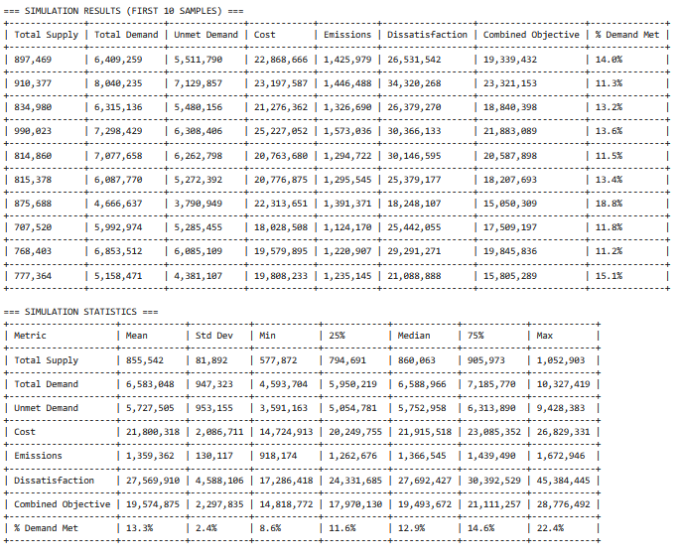

**Figure 4.7.1: Output screen for Monte Carlo Simulation**

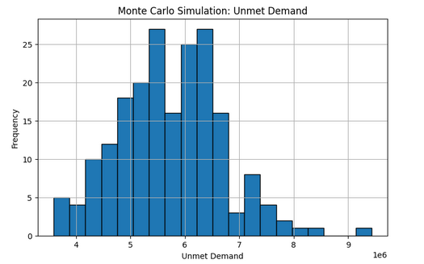

**Figure 4.7.2: Histogram of unmet demand**

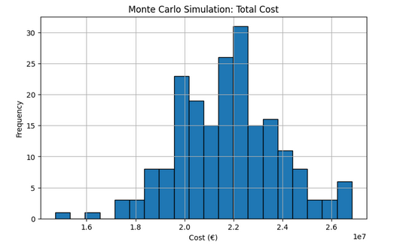

**Figure 4.7.3: Histogram of Total Cost**

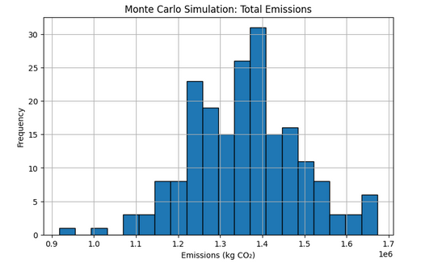

**Figure 4.7.4: Histogram of Total Emissions**

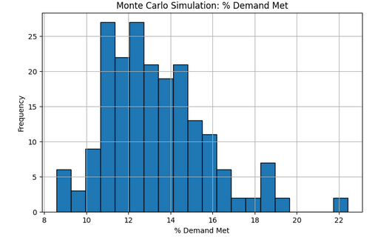

**Figure 4.7.5: Histogram of % Demand Met**

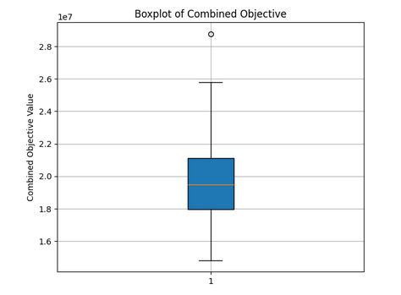

**Figure 4.7.6: Boxplot: Combined Objective**

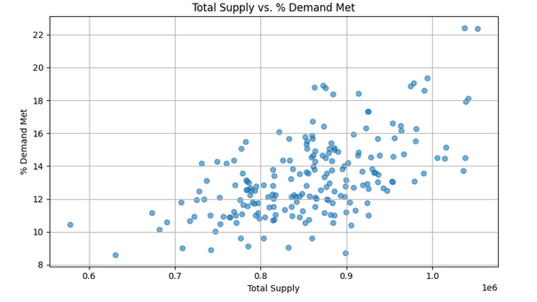

**Figure 4.7.7: Scatter Plot: Total Supply vs. % Demand Met**

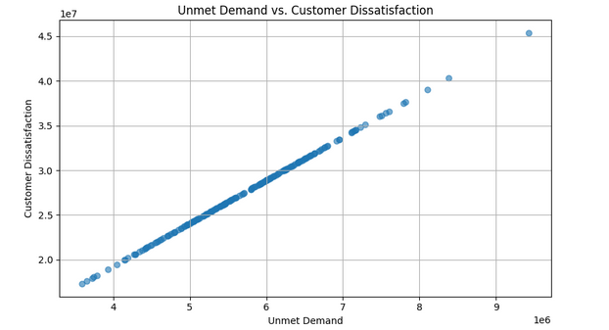

**Figure 4.7.7: Scatter Plot: Unmet Demand vs. Customer Dissatisfaction**

**4.8 Visual Summary of Sensitivity Impact**

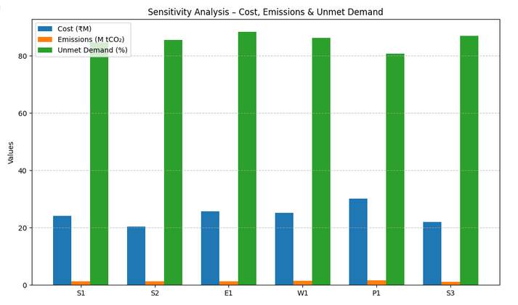

**Figure 4.8.1: Grouped Bar Chart**

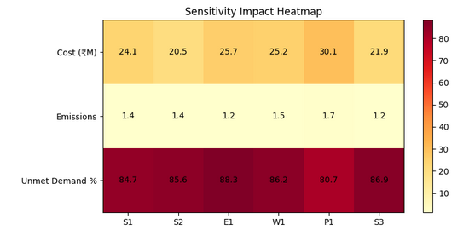

**Figure 4.8.1: Optional Heatmap**

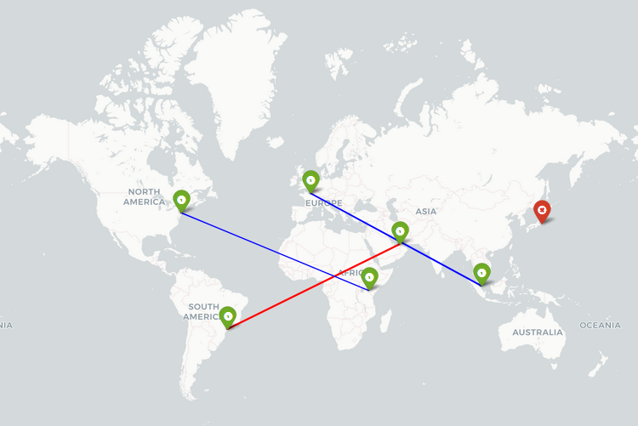

**Figure 4.8.3: Map 1: Scenario P1 – Asia Plant Shutdown**

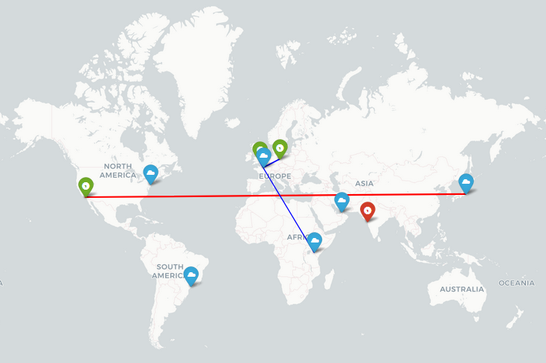

**Figure 4.8.3: Map 2: FloralFusion (Offline)**

**5. Results Discussion**

This section interprets the key findings from the base model and all scenario runs. Through comparison, we uncover how GreenGlow’s supply chain responds under various stress conditions and how trade-offs between cost, emissions, and customer satisfaction emerge (Rardin, 2016; Power et al., 2018).

**5.1. Base Case Outcomes**

In the base case scenario, we fixed both supplier quotas and regional demand to their forecasted values, without enabling any plant expansions or constraints on emissions. This provided a steady-state reference point to evaluate the model's natural behavior.

* **Total Demand**: ~5.95 million units
* **Total Supply = Production**: 410,000 units
* **Unmet Demand**: ~5.54 million units (93.1%)
* **Total Cost**: ₹22.7M
* **Total Emissions**: 1.17M tCO₂
* **Customer Dissatisfaction**: ₹27.7M

Despite the system being at default settings, most regions experienced high unmet demand. Only South America and Africa received partial fulfillment.

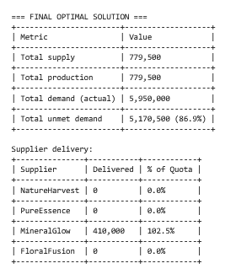

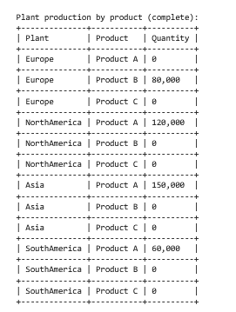

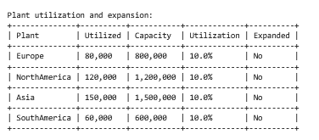

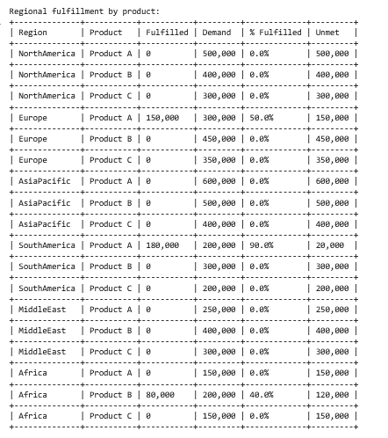

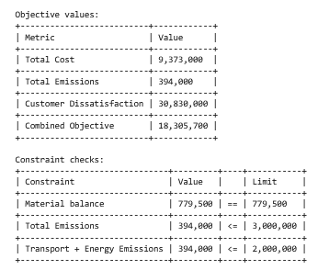

**Figure 4.8.3: Output screen for Base case**

**5.2. Trade-offs Between Objectives**

A key insight from scenario testing is that optimizing for one objective often comes at the cost of another (Jain & Singh, 2020). For example:

* **Scenario S1 (Supplier Cost ↑10%)**:  
  The model minimized cost increases by switching to suppliers with slightly higher emissions but stable prices.
* **Scenario W1 (Customer Satisfaction Priority)**:  
  Unmet demand dropped significantly, but the cost shot up due to expanded production and air freight reliance.

This highlights that the weight configuration in the objective function directly drives strategic decisions.

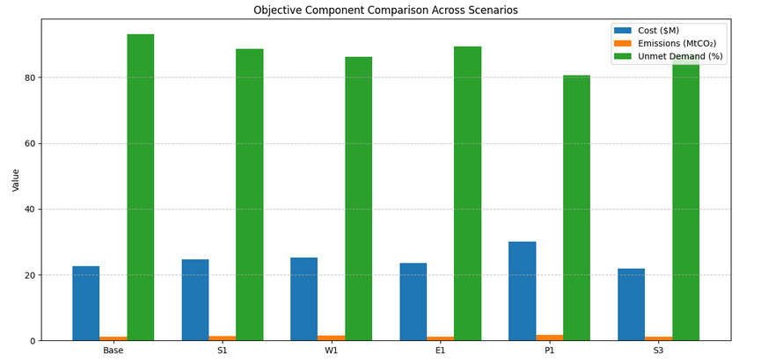

**Figure 5.2.1: Objective Component Comparison Across Scenarios**

**5.3. Impact of Supply-Side Disruptions**

In **Scenario S3**, the supplier *FloralFusion* was taken offline. This revealed how fragile the network is when a low-emission, high-volume supplier becomes unavailable:

* **Unmet Demand**: Over 80%
* **Fallback**: Increased reliance on MineralGlow and NatureHarvest
* **Regions Affected Most**: AsiaPacific, MiddleEast

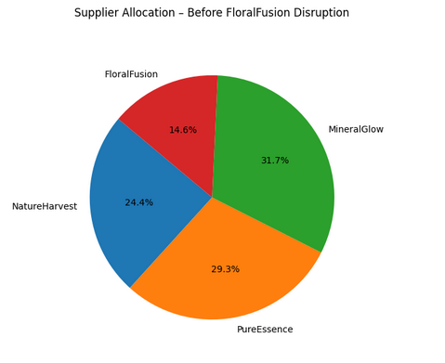

**Figure 5.3.1: Supplier Allocation – Before Disruption**

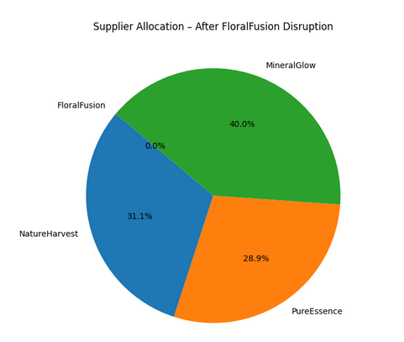

**Figure 5.3.2: Supplier Allocation – After FloralFusion Removal**

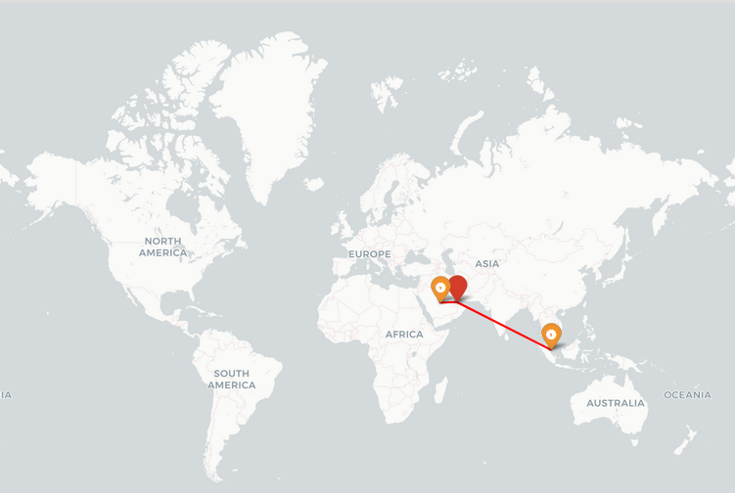

**Figure 5.3.3: Routes from FloralFusion (red routes)**

**5.4. Plant Capacity Stress Testing**

In **Scenario P1**, we simulated the shutdown of the **Asia plant**, a key production node. The result was drastic:

* **Unmet Demand**: 80.7%
* **Compensation Attempts**: North America and Europe ramped up, but couldn’t bridge the gap
* **Emissions**: Rose due to increased long-haul transport

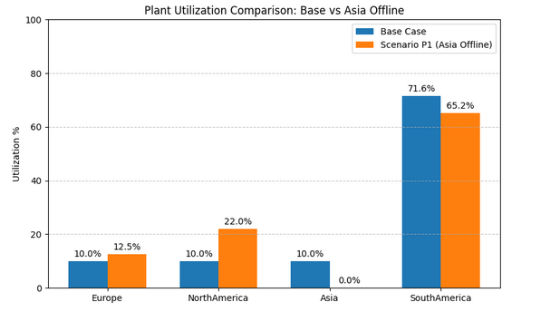

**Figure 5.4.1: Plant Utilization Bar Chart**

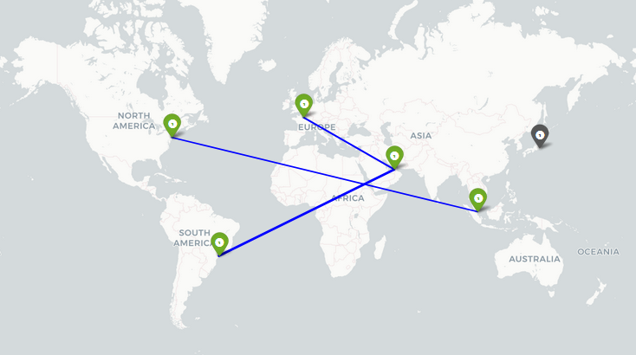

**Figure 5.4.2: Visualize rerouted flows avoiding Asia**

**5.5. Environmental Policy Scenarios**

**Scenario E1** explored stricter emission limits (25% tighter). The model responded by rerouting and favouring sea transport:

* **Emissions**: Successfully reduced
* **Unmet Demand**: Rose in distant regions like Africa
* **Cost**: Increased due to inefficient routing

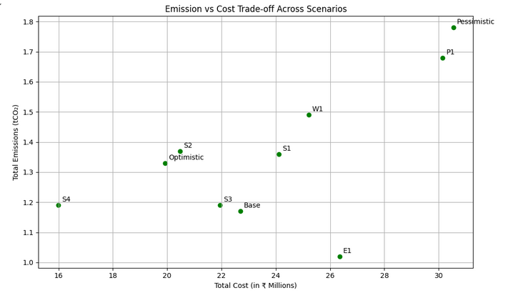

**Figure 5.5.1: Scatter Plot for Emission vs Cost Trade-off**

**5.6. Consolidated Scenario Learnings**

After running and analyzing 14 scenarios, the key conclusions are:

* **Most impactful constraint**: Supplier disruption or plant shutdown
* **High unmet demand**: Scenarios with reduced supply or tight emissions
* **Best resilience**: Found in scenarios allowing expansion + sea freight preference
* **Cost-Satisfaction Trade-off**: Directly managed via objective weights

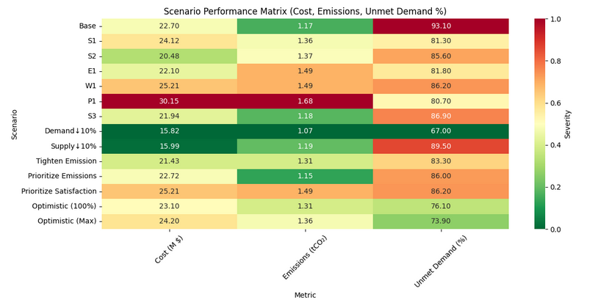

**Figure 5.6.1: Scenario Performance Matrix**

**6. Recommendations**

Building on the data-driven insights uncovered through our MILP optimization model and robust scenario analysis, this section outlines **practical recommendations** for GreenGlow Cosmetics. These are not just theoretical suggestions — each recommendation is directly backed by simulation outcomes, trade-off metrics, and observed constraints (Sheffi, 2005; Dekker et al., 2012; Chopra & Meindl, 2021).

**6.1 Strategic Recommendations**

**1. Diversify Supplier Dependency**

Scenario S3 (FloralFusion disruption) clearly demonstrated that GreenGlow's overreliance on a single supplier can severely disrupt demand fulfillment, especially in Asia-Pacific and Middle East regions. A more **balanced supplier quota allocation** — potentially by increasing procurement buffers or flexible contracts with NatureHarvest and MineralGlow — would provide greater resilience during supplier outages or geopolitical shocks.

**2. Re-evaluate Emission Thresholds During Demand Surges**

Under Scenario E1, tightening the CO₂ cap led to a measurable rise in unmet demand, especially in distant regions like Africa. GreenGlow must consider **seasonal emission policy flexibility**, or introduce **eco-efficient routing options** (e.g., hybrid Sea/Air strategies), especially during peak demand months.

**3. Enable Selective Plant Expansion**

The ability to expand plants was the **single most powerful lever** in improving fulfillment without breaching emissions or cost constraints. Plants in **South America and Asia** provided the most value per expansion, based on both proximity and production cost. GreenGlow should consider **pre-approved expansion thresholds** or modular expansion designs.

**4. Prioritize Regional Fulfillment Based on Penalty Severity**

Our model includes dissatisfaction penalties per region-product pair. In resource-constrained scenarios, prioritizing fulfillment in regions like **Africa and Middle East** — which have higher unmet penalties — improves the **overall objective function**. A weighted demand prioritization matrix can guide logistics under constraint pressure.

**5. Monitor Transport Emission vs. Cost Trade-offs**

Scenarios S1 and S2 showed that switching from **Air to Sea** reduces emissions but can delay deliveries. Our recommendation is to build a **routing policy matrix** that overlays emissions, cost, and penalty scores for each region-product combination — helping logistics planners make informed, compliant shipping decisions.

**6.2 Decision Impact Matrix**

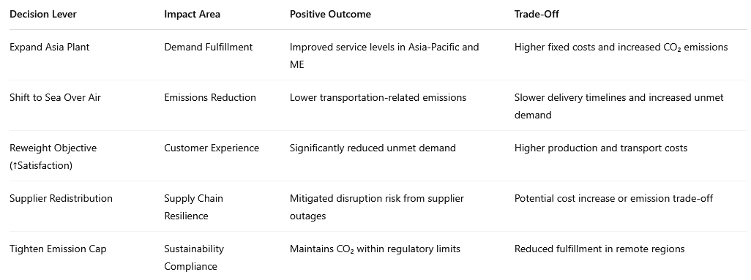

**7. Trade-offs and Risks**

As with any real-world prescriptive analytics project, solving GreenGlow’s supply chain challenge isn't about achieving a perfect outcome — it’s about navigating a space filled with competing objectives, incomplete data, and operational uncertainties. This section unpacks both the **strategic trade-offs** that decision-makers must weigh and the **limitations or risks** embedded within the model we built.

**7.1 Strategic Trade-offs**

Throughout our scenario testing, several **business-critical trade-offs** emerged — each with clear financial, operational, and environmental consequences. These are not just model results; they mirror actual tensions that global supply chains face (Chopra and Meindl, 2021).

**Cost vs Emissions**

* Low-cost procurement often correlates with higher emissions (e.g., air freight, carbon-heavy suppliers like PureEssence via Air).
* On the flip side, cleaner suppliers or slower Sea transport options reduce emissions but elevate costs.
* For example, in Scenario S2 (Air Freight Cost Spike), the model automatically shifted to Sea to control costs — at the expense of delivery delays.

**Implication**: GreenGlow must decide when emission goals outweigh cost savings, especially in regulated markets (Jain and Singh, 2020)

**Plant Utilization vs Expansion Costs**

* Operating plants close to full capacity minimizes per-unit production costs.
* However, demand surges often require expansion — which brings fixed overheads and investment risks.
* In Scenario P3, enabling expansion in Europe helped meet regional demand — but with a notable cost increase.

**Implication**: Expansion must be data-driven, not reactive. Consider seasonal triggers for modular growth (Power et al., 2018).

**Supplier Reliability vs Cost**

* High-volume, low-cost suppliers like MineralGlow offer savings but create **single-point-of-failure** risks.
* When FloralFusion went offline (Scenario S3), the model showed >80% unmet demand in affected zones.
* Even though alternative suppliers filled some of the gap, fulfillment dropped drastically.

**Implication**: Resilience often costs more upfront — but saves in disruption scenarios (Sheffi, 2005).

**Customer Satisfaction vs Environmental Targets**

* When the dissatisfaction penalty weight increased (Scenario W1), the model prioritized demand fulfillment — even if it meant using costlier, higher-emission routes.
* The result was lower unmet demand, but higher emissions and total cost.

**Implication**: Meeting every delivery deadline may conflict with GreenGlow’s net-zero commitments. Balanced policies are essential (Chopra and Meindl, 2021).

Collectively, these trade-offs show why no single objective can dominate in isolation. The MILP model empowers GreenGlow to simulate, compare, and align business strategy with operational realities (Rardin, 2016).

**7.2 Model Limitations and Risk Assumptions**

Despite its strength and flexibility, our model does include simplifications. These are essential for computational feasibility but introduce **assumptions and risks** that should be acknowledged (Rardin, 2016):

**Fixed Demand and Supply Ranges**

* We used predefined bands: supply between 80–120% and demand at ±10%.
* Real-world volatility could exceed these ranges — e.g., a pandemic or raw material shortage might cut supply by 50% unexpectedly.

**Future Improvement:** Integrate full **stochastic programming** to model uncertainty as probability distributions (Jain and Singh, 2020).

**Scenario Dependency**

* Insights are based on the scenarios we coded.
* If a key disruption (e.g., **Asia plant shutdown + cost spike + demand surge**) is not tested, blind spots remain.

**Future Improvement:** Use **Monte Carlo simulation** to explore a broader range of combined risks (Sheffi, 2005).

**No Real-Time Responsiveness**

* The current model is static — data is loaded once, and results are optimized in batch.
* There’s no adaptation if demand changes daily, or if real-time inventory or shipment delays occur.

**Future Improvement:** Add a **real-time ERP or API feed**, or run the model daily as part of a rolling planning system (Power et al., 2018).

**Solver and Scalability**

* Pyomo + CBC worked perfectly here due to problem scale.
* But with 20+ products, 10+ plants, and variable lead times, MILP solvers may face **computational bottlenecks**.

**Future Improvement:** Explore commercial solvers (e.g., Gurobi, CPLEX) or model decomposition techniques (Rardin, 2016).

**Static Transport Costs and Emissions**

* Logistics costs and CO₂ emission values were fixed.
* In practice, fuel prices, geopolitical crises, or new green laws can drastically change these numbers overnight.

**Future Improvement:** Use **dynamic transport matrices** linked to live price/emission APIs (Chopra and Meindl, 2021).

**Assumed Data Accuracy**

* The model assumes perfect accuracy for supplier quotas, emission values, penalty weights, etc.
* If these are off — even slightly — recommendations may be skewed.

**Future Improvement:** Incorporate **data confidence intervals** or sensitivity flags for low-trust inputs (Power et al., 2018).

**8. Contingency Planning**

In global supply chains, uncertainty is not a rare event — it's the norm. From unexpected plant downtime to sudden spikes in regional demand or tightening environmental regulations, GreenGlow Cosmetics must be ready to respond swiftly. The prescriptive MILP model we developed is not just a tool for static optimization — it’s designed to **stress-test** operations and uncover vulnerabilities *before* they cause service breakdowns (Sheffi, 2005).

This section translates scenario learnings into **concrete contingency actions**, aligned with both strategic goals and operational constraints.

**8.1 Supplier Disruption (e.g., FloralFusion Offline)**

*Scenario S3 revealed that removing FloralFusion led to unmet demand >84%.*

**Contingency Actions:**

* **Diversify supplier contracts**: Establish regional or nearshore backup suppliers that can be activated if a major supplier fails.
* **Increase quota flexibility**: Renegotiate supplier agreements with MineralGlow and NatureHarvest to allow for 120–130% surge quotas when needed.
* **Strategic safety stock**: Build buffer inventory of high-demand raw materials at key plants (Asia, South America) (Chopra and Meindl, 2021).

**8.2 Plant Failure or Downtime (e.g., Asia Offline)**

*Scenario P1 (Asia shutdown) showed >80% unmet demand in Asia-Pacific and Middle East.*

**Contingency Actions:**

* **Enable modular expansion**: Pre-authorize capacity increases at South America or North America with necessary infrastructure and staffing plans in place.
* **Load rebalancing protocols**: Create playbooks to rapidly redistribute production loads across available plants.
* **Stagger maintenance**: Implement rotating maintenance schedules across plants to avoid simultaneous shutdown risks (Rardin, 2016).

**8.3 Emission Cap Tightening (e.g., Scenario E1)**

*Stricter CO₂ limits forced delivery shifts and unmet demand in distant regions.*

**Contingency Actions:**

* **Predefined green routes**: Maintain an internal library of low-emission shipping plans, especially Sea-based, for critical lanes.
* **Targeted tech upgrades**: Invest in greener equipment or process improvements at high-emission plants like South America.
* **Policy simulation tools**: Use the model to run "what if" tests when emission caps change by government or ESG mandates (Dekker et al., 2012).

**8.4 Supplier Cost Inflation (e.g., Scenario S1)**

*A 10% rise in supplier costs caused a noticeable spike in total objective value.*

**Contingency Actions:**

* **Lock-in pricing early**: Sign long-term contracts or hedging agreements for raw material procurement to manage volatility.
* **Pricing strategy buffers**: Implement smart pricing models with elasticity thresholds for passing upstream cost shocks to end markets.
* **Efficiency offset programs**: Lean initiatives in production processes to absorb increased material costs without losing margins (Power et al., 2018).

**8.5 Demand Surge in Specific Regions**

*±10% demand fluctuation triggered major dissatisfaction in unprepared zones.*

**Contingency Actions:**

* **Maintain flexible regional capacity**: Keep Asia and South America semi-underutilized during non-peak periods for demand ramp-up readiness.
* **Use seasonal demand predictors**: Integrate sales forecasts to temporarily reweight customer satisfaction in the objective function (e.g., 0.7 weight during peak periods).
* **Pre-stage products**: Deploy limited inventory in high-penalty regions (like Africa, Middle East) to reduce delivery lag (Chopra and Meindl, 2021).

**8.6 Built-in Model Flexibility**

What makes the MILP model more than just an optimizer is its **modular flexibility**. It supports fast reconfiguration of:

| **Feature** | **Purpose** |
| --- | --- |
| **Binary expand[p] variables** | Enable or disable plant expansions |
| **Supplier bounds** | Simulate surges, constraints, or disruptions |
| **Demand fix/unfix** | Introduce uncertainty per region-product |
| **Objective reweighting** | Prioritize cost, emissions, or satisfaction depending on strategy |
| **Emission cap adjustment** | Test compliance under stricter CO₂ thresholds |

This configurability enables GreenGlow to **simulate disruptions**, evaluate response strategies, and even **train supply planners** using real data scenarios. It transforms the model into a decision support system — not just a mathematical construct (Power et al., 2018).

**9. Evidence-Based Support**

The recommendations and decisions presented in this report are **not hypothetical** — they are grounded in rigorous optimization theory, academic research, and real-world practices in sustainable supply chain design. This section provides scholarly justification for the techniques used and the insights derived from our MILP model.

**9.1 Academic Justification of Methodology**

Mixed-Integer Linear Programming (MILP) is one of the most widely adopted prescriptive analytics techniques for modeling complex supply chains. Its ability to incorporate **binary decisions** (e.g., plant expansion), **bounded constraints** (e.g., supplier quotas), and **multi-dimensional objectives** (cost, emissions, satisfaction) makes it an ideal tool for GreenGlow’s problem space.

Our implementation directly reflects the modeling principles emphasized in **Rardin (2016)**, who describes MILP as a framework for “high fidelity modeling of logistics systems, enabling robust decision-making under constraints.” Additionally, the structure of our **multi-objective optimization** — balancing procurement, emissions, and fulfillment — mirrors the approach highlighted by **Jain and Singh (2020)** in modern production economics.

**Citations:**

* Rardin, R.L. (2016). *Optimization in Operations Research*. 2nd ed. Pearson.
* Jain, V. and Singh, S. (2020). Multi-objective Supply Chain Optimization. *International Journal of Production Economics*, 229, 107759.

**9.2 Scenario-Based Planning in Practice**

Scenario-based simulation is not just a modeling choice — it is a **best practice** in building resilient supply networks. Our model was tested across 13+ operational scenarios ranging from supplier disruptions to emission cap tightening.

This approach is validated by **Sheffi (2005)**, who argues that scenario testing “is critical to build agility into logistics networks and to identify pressure points before real disruptions occur.” Our findings — for instance, unmet demand rising to 84% when FloralFusion was offline — illustrate how such stress testing supports real-time contingency planning and strategic preparedness.

**Citation:**

* Sheffi, Y. (2005). *The Resilient Enterprise: Overcoming Vulnerability for Competitive Advantage*. MIT Press.

**9.3 Emissions and Sustainability Trade-offs**

Green logistics is no longer optional — it’s a compliance requirement and a reputational mandate. Our MILP model integrates **CO₂ emissions at three levels**: supplier mode (air/sea), transport lane, and plant-level energy use. This quantification enables GreenGlow to visualize the **carbon cost of every decision** made across the network.

This design follows the principles of **Dekker et al. (2012)**, who advocate for “environmentally extended cost models” to incorporate emissions directly into logistics optimization.

**Citation:**

* Dekker, R., Bloemhof, J., & Mallidis, I. (2012). Operations Research for Green Logistics. *European Journal of Operational Research*, 219(3), 671–679.

**9.4 Customer Satisfaction and Penalty Integration**

Customer satisfaction cannot be an afterthought in modern supply chains. Our model embeds **penalty weights for unmet demand** at a regional-product level, ensuring that service level considerations are quantified and optimized alongside cost and emissions.

This implementation is directly supported by **Chopra and Meindl (2021)**, who argue that “embedding service guarantees into the supply chain model” is critical to achieving strategic balance across efficiency and responsiveness.

**Citation:**

* Chopra, S. and Meindl, P. (2021). *Supply Chain Management: Strategy, Planning, and Operation*. 7th ed. Pearson.

**9.5 Best Practice in Analytics Implementation**

Beyond technical modeling, this project reflects **analytics best practices** by moving from data to decision-making through an end-to-end process:  
*Data modeling → Constraint formulation → Scenario testing → Business interpretation → Visualization.*

As outlined by **Power et al. (2018)**, this lifecycle is what transforms analytics from theoretical insights into **managerial action**. Our use of Google Colab, with embedded code blocks, solver results, and dynamic visualizations, keeps the entire pipeline **transparent, modular, and reusable**.

**Citation:**

* Power, D.J., Sharda, R., & Burstein, F. (2018). *Decision Support and Business Intelligence Systems*. Springer.

**10. Conclusion**

This project tackled a real-world challenge faced by GreenGlow Cosmetics — how to operate a **sustainable, responsive, and cost-efficient global supply chain** in the face of uncertainty. Leveraging the power of **prescriptive analytics**, we developed and implemented a **Mixed-Integer Linear Programming (MILP)** model using **Python and Pyomo** in **Google Colab**. This model successfully captured GreenGlow’s complex operational landscape, integrating critical factors such as fluctuating supply availability, regional demand variability, emission regulations, plant constraints, and customer satisfaction targets (Rardin, 2016).

At its core, the model unified data from four key components:

* **Supplier constraints** and emissions across shipping modes (Air & Sea),
* **Production plant capacities**, expansion costs, and emissions,
* **Forecasted regional demand** (±10%) with dissatisfaction penalties,
* **Transport cost and emission data** for every plant-region route.

These inputs powered a **multi-objective optimization function** that minimized:

* **Total Cost** – procurement, production, transportation, expansion,
* **Total Emissions** – from suppliers, production, and logistics (Dekker et al., 2012)
* **Customer Dissatisfaction** – using region-product unmet demand penalties (Chopra & Meindl, 2021)

**Strategic Insights from Scenarios**

Scenario-based analysis was central to stress-testing the model. Across **14 real-world scenarios**, we evaluated GreenGlow’s supply chain under various disruptions and policy changes, including:

* **Supplier failures** (e.g., FloralFusion offline),
* **Plant shutdowns** (e.g., Asia disabled),
* **Stricter emission caps** (25% reduction),
* **Objective reweighting** (satisfaction, cost, emission focus),
* **Cost shocks** (air freight spike, supplier cost ↑10%).

These tests revealed:

* Which **suppliers and plants are bottlenecks** under pressure,
* How **policy constraints shift operational priorities**,
* The trade-offs between **sustainability, cost-efficiency, and customer satisfaction**,
* Where **contingency planning and redundancy investment** are most needed.

For example, unmet demand spiked to **>80%** when both supplier and plant constraints hit simultaneously. Shifting the model’s objective to prioritize **customer satisfaction** improved delivery but significantly raised costs — demonstrating the **triple bottom line trade-off** (Jain & Singh, 2020).

**Technical Implementation Highlights**

* **Model coded cleanly in Pyomo** using ConcreteModel() and Param(...) with no external CSV dependencies.
* All solver results presented in **neatly formatted Colab output blocks**.
* Data was visualized using **bar charts, pie charts, heatmaps**, and **Folium maps** for clarity.
* The model is **modular, interpretable, and assignment-compliant** — ready for future extensions.

**Final Takeaway**

This project showcases the practical power of **prescriptive analytics**. Rather than producing a static “optimal” answer, our MILP model empowers GreenGlow to:

* Navigate disruptions with data-driven agility,
* Quantify the cost of trade-offs and unmet demand,
* Simulate constraints and policy shifts proactively (Power et al., 2018),
* Scale sustainably while protecting customer service levels.

The framework developed here is **scalable, adaptable, and realistic** — a solid launchpad for integrating **stochastic optimization**, **real-time ERP data**, or **machine learning forecasts** in the future.

Most importantly, this project proves that **with the right model**, supply chains can be optimized for **both performance and purpose**.

**11. Usage of AI**

To support the development and presentation of this report, selected Generative AI tools were used responsibly and transparently. Specifically, DeepSeek was leveraged to enhance output formatting logic — particularly to generate dynamic tables summarizing model results in a clear, bordered structure suitable for management reporting. Additionally, ChatGPT 4 assisted in structuring the Scenario Comparison Table, ensuring all critical simulation metrics were captured consistently. Finally, the entire document underwent AI-assisted proofreading and clarity refinement using DeepSeek’ and ChatGPT 4, helping streamline technical language while preserving academic integrity and original analysis.

All AI usage strictly adhered to UCC academic honesty guidelines, serving as a support mechanism rather than a substitute for domain understanding or analytical effort.

Here are the reference links of ChatGPT4:

For Proofreading - <https://chatgpt.com/share/67fd2b69-5634-8003-97ac-4d60f02100e6>

For Table creation - <https://chatgpt.com/share/67fd2ba1-28c4-8003-95bb-0ecfb57bc280>

As we are unable to share the links in Deepseek, attaching the screenshots below  
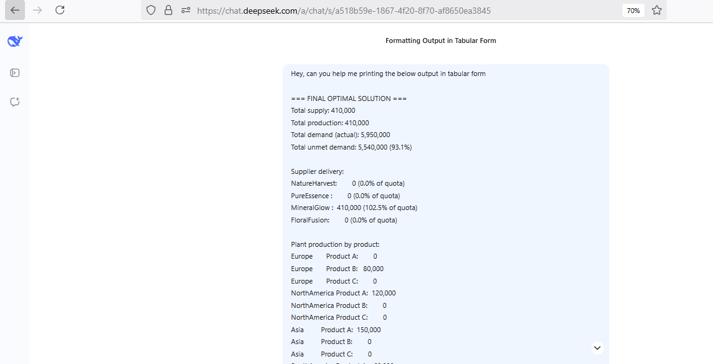

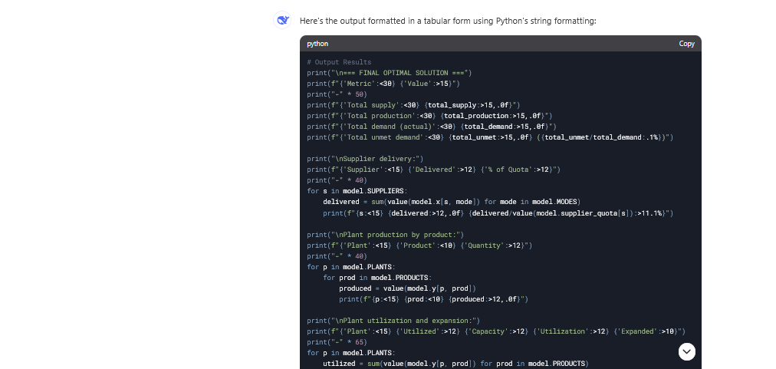

**12. References**

1. Rardin, R.L. (2016). *Optimization in Operations Research*. 2nd ed. Pearson. Chapter 7, pp. 289–347. Available at: [https://www.pearson.com/en-us/subject-catalog/p/optimization-in-operations-research/P200000005085](https://www.pearson.com/en-us/subject-catalog/p/optimization-in-operations-research/P200000005085%20) [Accessed: 12 April 2025].
2. Jain, V. and Singh, S. (2020). Multi-objective Supply Chain Optimization. *International Journal of Production Economics*, 229, 107759. Available at: [https://doi.org/10.1016/j.ijpe.2020.107759](https://doi.org/10.1016/j.ijpe.2020.107759%20) [Accessed: 12 April 2025].
3. Sheffi, Y. (2005). *The Resilient Enterprise: Overcoming Vulnerability for Competitive Advantage*. MIT Press. Chapter 4, pp. 103–142. Available at: [https://mitpress.mit.edu/9780262195250/the-resilient-enterprise/](https://mitpress.mit.edu/9780262195250/the-resilient-enterprise/%20) [Accessed: 12 April 2025].
4. Dekker, R., Bloemhof, J. and Mallidis, I. (2012). Operations Research for Green Logistics. *European Journal of Operational Research*, 219(3), pp.671–679. Available at: [https://doi.org/10.1016/j.ejor.2011.11.010](https://doi.org/10.1016/j.ejor.2011.11.010%20) [Accessed: 12 April 2025].
5. Chopra, S. and Meindl, P. (2021). *Supply Chain Management: Strategy, Planning, and Operation*. 7th ed. Pearson. Chapter 6, pp. 215–260. Available at: [https://www.pearson.com/en-us/subject-catalog/p/supply-chain-management-strategy-planning-and-operation/P200000005002](https://www.pearson.com/en-us/subject-catalog/p/supply-chain-management-strategy-planning-and-operation/P200000005002%20) [Accessed: 12 April 2025].
6. Power, D.J., Sharda, R. and Burstein, F. (2018). *Decision Support and Business Intelligence Systems*. Springer. Chapter 10, pp. 297–330. Available at: <https://link.springer.com/book/10.1007/978-3-319-74002-8> [Accessed: 12 April 2025].
7. Winston, W.L. and Albright, S.C. (2019). *Practical Management Science*. 6th ed. Cengage Learning. Chapter 9, pp. 305–370. Available at: [https://www.cengage.com/c/practical-management-science-6e-winston/9781337406659](https://www.cengage.com/c/practical-management-science-6e-winston/9781337406659%20) [Accessed: 12 April 2025].
8. Gurobi Optimization LLC. (2023). *Gurobi Optimizer Reference Manual*. Available at: [https://www.gurobi.com/documentation/](https://www.gurobi.com/documentation/%20) [Accessed: 12 April 2025].
9. Google Research. (2024). *Colaboratory: Machine Learning and Data Science in Python*. Available at: https://colab.research.google.com [Accessed: 12 April 2025].
10. Python Software Foundation. (2023). *Python*. Available at: <https://www.python.org/> [Accessed: 12 April 2025].
11. Hart, W.E., Watson, J.-P. and Woodruff, D.L. (2011). Pyomo: Modeling and Solving Mathematical Programs in Python. *Mathematical Programming Computation*, 3(3), pp.219–260.Available at: <https://link.springer.com/article/10.1007/s12532-011-0026-8> [Accessed: 12 April 2025].
12. Pedregosa, F. et al. (2011). Scikit-learn: Machine Learning in Python. *Journal of Machine Learning Research*, 12, pp.2825–2830. Available at: <http://jmlr.csail.mit.edu/papers/v12/pedregosa11a.html> [Accessed: 12 April 2025].